#load the csv file and provide the name as lv  
  
setwd('/Users/dsing001/LV/R')  
  
#install.packages('ggplot2')  
#install.packages('discretization')  
#install.packages('randomForest')  
#install.packages('ROCR')  
#install.packages('LV')  
#install.packages('unbalanced')  
#install.packages('rpart')  
#install.packages('StatMatch')  
  
library(ggplot2)

## Warning: package 'ggplot2' was built under R version 3.1.3

library(discretization)

## Warning: package 'discretization' was built under R version 3.1.2

library(randomForest)

## Warning: package 'randomForest' was built under R version 3.1.2

## randomForest 4.6-10  
## Type rfNews() to see new features/changes/bug fixes.

library(ROCR)

## Warning: package 'ROCR' was built under R version 3.1.2

## Loading required package: gplots

## Warning: package 'gplots' was built under R version 3.1.2

## KernSmooth 2.23 loaded  
## Copyright M. P. Wand 1997-2009  
##   
## Attaching package: 'gplots'  
##   
## The following object is masked from 'package:stats':  
##   
## lowess

library(LV)  
library(unbalanced)

## Warning: package 'unbalanced' was built under R version 3.1.2

## Loading required package: FNN

## Warning: package 'FNN' was built under R version 3.1.2

## Loading required package: RANN

## Warning: package 'RANN' was built under R version 3.1.2

library(rpart)

## Warning: package 'rpart' was built under R version 3.1.2

library(StatMatch)

## Warning: package 'StatMatch' was built under R version 3.1.2

## Loading required package: proxy

## Warning: package 'proxy' was built under R version 3.1.2

##   
## Attaching package: 'proxy'  
##   
## The following objects are masked from 'package:stats':  
##   
## as.dist, dist  
##   
## The following object is masked from 'package:base':  
##   
## as.matrix  
##   
## Loading required package: clue

## Warning: package 'clue' was built under R version 3.1.2

## Loading required package: survey

## Warning: package 'survey' was built under R version 3.1.2

## Loading required package: grid  
##   
## Attaching package: 'survey'  
##   
## The following object is masked from 'package:graphics':  
##   
## dotchart  
##   
## Loading required package: lpSolve

## Warning: package 'lpSolve' was built under R version 3.1.2

# Select any file name and class column  
filename <- 'LendingClub.csv'  
header <- TRUE  
filename

## [1] "LendingClub.csv"

clscol='Class'  
  
#run prelim processing  
X <- read.csv(file=filename,header=header)  
  
#it might not work with all of data. I have tried with many things and it worked. But you miight need to make some changes.  
  
prelimprocessing(X,clscol=clscol,timetovieweachinput=2,remmissingdatabeforeprocessing=TRUE,generategraphs=TRUE)

## [1] "Rows with missing data 52"  
## numofmissingrows  
## Use.Of.Credit.Line 52  
## Debt.To.Income.Ratio 1  
## No..Delinquencies.In.Last.2.Years 1  
## FICO.Credit.Score 1  
## No..Inquiries.In.Last.6.Months 1  
## No..Of.Credit.Lines 1  
## No..Adverse.Public.Records 1  
## Total.Credit.Balance 1  
## Total.Number.Of.Credit.Lines 1  
## Loan.Amount 0  
## Loan.Term 0  
## Employment.Length 0  
## Home.Ownership 0  
## Annual.Income 0  
## Loan.Purpose 0  
## Address.State 0  
## Earliest.Credit.Line.Opened 0  
## Months.Since.Last.Delinquency 0  
## Loan.Application.Description 0  
## No..Of.Public.Record.Bankruptcies 0  
## Class 0  
## 'data.frame': 24724 obs. of 21 variables:  
## $ Loan.Amount : int 25000 7000 1200 10800 7500 3000 4000 5600 3200 4000 ...  
## $ Loan.Term : Factor w/ 2 levels "36 Months","60 Months": 1 1 1 1 1 1 1 1 1 1 ...  
## $ Employment.Length : num 0.5 0.5 10 6 3 3 0.5 1 5 0.5 ...  
## $ Home.Ownership : Factor w/ 5 levels "MORTGAGE","NOne",..: 5 5 4 5 5 1 1 5 5 1 ...  
## $ Annual.Income : num 85000 65000 54000 32000 85000 80800 148000 45000 54000 60000 ...  
## $ Loan.Purpose : Factor w/ 15 levels "0","Car","Credit Card",..: 4 3 4 4 4 3 3 4 4 2 ...  
## $ Address.State : Factor w/ 51 levels "","AK","AL","AR",..: 6 35 44 8 6 44 44 22 21 24 ...  
## $ Debt.To.Income.Ratio : num 19.48 14.29 5.47 11.63 8.1 ...  
## $ No..Delinquencies.In.Last.2.Years: Factor w/ 10 levels "Eight","Five",..: 5 5 5 5 5 6 5 5 5 5 ...  
## $ Earliest.Credit.Line.Opened : num 34380 36821 31068 35411 36846 ...  
## $ FICO.Credit.Score : int 735 705 675 680 710 665 725 665 740 720 ...  
## $ No..Inquiries.In.Last.6.Months : int 0 0 0 1 1 0 0 0 0 0 ...  
## $ Months.Since.Last.Delinquency : int 0 0 64 58 0 13 0 38 0 0 ...  
## $ No..Of.Credit.Lines : int 10 7 5 14 3 13 11 5 7 14 ...  
## $ No..Adverse.Public.Records : Factor w/ 5 levels "Four","None",..: 2 2 2 2 2 2 2 3 2 2 ...  
## $ Total.Credit.Balance : int 28854 33623 2584 3511 33667 4740 50000 3839 3198 24220 ...  
## $ Use.Of.Credit.Line : num 52.1 76.7 40.4 25.6 73.2 39.5 51 76.8 51.1 68.6 ...  
## $ Total.Number.Of.Credit.Lines : int 42 7 31 40 11 23 19 9 11 33 ...  
## $ Loan.Application.Description : int 308 71 748 403 293 487 363 340 141 824 ...  
## $ No..Of.Public.Record.Bankruptcies: Factor w/ 3 levels "None","One","Two": 1 1 1 1 1 1 1 1 1 1 ...  
## $ Class : Factor w/ 2 levels "Creditworthy",..: 1 1 1 1 1 1 1 2 1 2 ...  
## NULL  
## Loan.Amount Loan.Term Employment.Length Home.Ownership   
## Min. : 500 36 Months:20540 Min. : 0.000 MORTGAGE:10715   
## 1st Qu.: 5500 60 Months: 4184 1st Qu.: 2.000 NOne : 4   
## Median :10000 Median : 4.000 OTHER : 96   
## Mean :11126 Mean : 4.814 OWN : 2014   
## 3rd Qu.:15000 3rd Qu.: 8.000 RENT :11895   
## Max. :35000 Max. :10.000   
##   
## Annual.Income Loan.Purpose Address.State   
## Min. : 4000 Debt Consolidation:11712 CA : 4478   
## 1st Qu.: 41000 Credit Card : 3231 NY : 2400   
## Median : 60000 Other : 2594 FL : 1740   
## Mean : 67219 Home Improvement : 1718 TX : 1739   
## 3rd Qu.: 83004 Major Purchase : 1321 NJ : 1100   
## Max. :200000 Small Business : 1171 VA : 907   
## (Other) : 2977 (Other):12360   
## Debt.To.Income.Ratio No..Delinquencies.In.Last.2.Years  
## Min. : 0.00 None :21933   
## 1st Qu.: 7.95 One : 2118   
## Median :13.28 Two : 469   
## Mean :13.24 Three : 148   
## 3rd Qu.:18.57 Four : 27   
## Max. :34.98 Five : 16   
## (Other): 13   
## Earliest.Credit.Line.Opened FICO.Credit.Score  
## Min. :30000 Min. :625.0   
## 1st Qu.:34409 1st Qu.:685.0   
## Median :36042 Median :705.0   
## Mean :35645 Mean :713.2   
## 3rd Qu.:37200 3rd Qu.:740.0   
## Max. :40075 Max. :845.0   
##   
## No..Inquiries.In.Last.6.Months Months.Since.Last.Delinquency  
## Min. :0.0000 Min. : 0.00   
## 1st Qu.:0.0000 1st Qu.: 0.00   
## Median :1.0000 Median : 0.00   
## Mean :0.9531 Mean : 12.84   
## 3rd Qu.:2.0000 3rd Qu.: 21.00   
## Max. :8.0000 Max. :106.00   
##   
## No..Of.Credit.Lines No..Adverse.Public.Records Total.Credit.Balance  
## Min. : 1.000 Four : 2 Min. : 0   
## 1st Qu.: 6.000 None :23435 1st Qu.: 3706   
## Median : 9.000 One : 1250 Median : 8906   
## Mean : 9.439 Three: 4 Mean :12512   
## 3rd Qu.:12.000 Two : 33 3rd Qu.:17264   
## Max. :49.000 Max. :50000   
##   
## Use.Of.Credit.Line Total.Number.Of.Credit.Lines  
## Min. : 0.00 Min. : 2.0   
## 1st Qu.: 24.20 1st Qu.:14.0   
## Median : 48.30 Median :21.0   
## Mean : 47.95 Mean :22.6   
## 3rd Qu.: 71.70 3rd Qu.:29.0   
## Max. :100.90 Max. :90.0   
##   
## Loan.Application.Description No..Of.Public.Record.Bankruptcies  
## Min. : 0.0 None:23717   
## 1st Qu.: 0.0 One : 1002   
## Median : 153.0 Two : 5   
## Mean : 257.2   
## 3rd Qu.: 379.0   
## Max. :1000.0   
##   
## Class   
## Creditworthy :20243   
## Uncreditworthy: 4481   
##   
##   
##   
##   
##   
## Loan.Amount Loan.Term Employment.Length Home.Ownership Annual.Income  
## 1 25000 36 Months 0.5 RENT 85000  
## 2 7000 36 Months 0.5 RENT 65000  
## Loan.Purpose Address.State Debt.To.Income.Ratio  
## 1 Debt Consolidation CA 19.48  
## 2 Credit Card NY 14.29  
## No..Delinquencies.In.Last.2.Years Earliest.Credit.Line.Opened  
## 1 None 34380.44  
## 2 None 36820.52  
## FICO.Credit.Score No..Inquiries.In.Last.6.Months  
## 1 735 0  
## 2 705 0  
## Months.Since.Last.Delinquency No..Of.Credit.Lines  
## 1 0 10  
## 2 0 7  
## No..Adverse.Public.Records Total.Credit.Balance Use.Of.Credit.Line  
## 1 None 28854 52.1  
## 2 None 33623 76.7  
## Total.Number.Of.Credit.Lines Loan.Application.Description  
## 1 42 308  
## 2 7 71  
## No..Of.Public.Record.Bankruptcies Class  
## 1 None Creditworthy  
## 2 None Creditworthy  
## [1] "start prining table of class data"  
##   
## Creditworthy Uncreditworthy   
## 20243 4481   
## [1] "end prining table of class data"  
## [1] 1 11 12 13 14 16 18 19  
## [1] "start converting all char to fact"  
## [1] "done converting all char to fact"  
## [1] "start removing factor cols which has more than 60 level of factors"  
## [1] "removing columns with very high levels list of columns is given below"  
## integer(0)  
## [1] "end removing factor cols which has more than 60 level of factors"  
## [1] "start find int columns which can be converted to factcol"  
## integer(0)  
## [1] "end find int columns which can be converted to factcol"  
## [1] "start findcorrelation "  
## integer(0)  
## Loan.Amount Employment.Length Annual.Income  
## Loan.Amount 1.0000000 0.1618603 0.4198879  
## Employment.Length 0.1618603 1.0000000 0.1786897  
## Debt.To.Income.Ratio Earliest.Credit.Line.Opened  
## Loan.Amount 0.06719359 -0.1673221  
## Employment.Length 0.05797882 -0.2419203  
## FICO.Credit.Score No..Inquiries.In.Last.6.Months  
## Loan.Amount 0.07294192 0.03135259  
## Employment.Length 0.04394509 0.01599744  
## Months.Since.Last.Delinquency No..Of.Credit.Lines  
## Loan.Amount -0.02535834 0.18661182  
## Employment.Length 0.04194617 0.09035516  
## Total.Credit.Balance Use.Of.Credit.Line  
## Loan.Amount 0.3397808 0.07625886  
## Employment.Length 0.1680961 0.03968587  
## Total.Number.Of.Credit.Lines  
## Loan.Amount 0.2441363  
## Employment.Length 0.2037415  
## Loan.Application.Description  
## Loan.Amount 0.07038432  
## Employment.Length -0.09971484  
## [1] "done findcorrelation "  
## [1] "start check_whether_features_are_related "  
## integer(0)  
## integer(0)  
## [1] "numeric columns with a correlation more than 0.3"  
## Loan.Amount Employment.Length Annual.Income  
## Loan.Amount TRUE FALSE TRUE  
## Employment.Length FALSE TRUE FALSE  
## Annual.Income TRUE FALSE TRUE  
## Debt.To.Income.Ratio FALSE FALSE FALSE  
## Earliest.Credit.Line.Opened FALSE FALSE FALSE  
## FICO.Credit.Score FALSE FALSE FALSE  
## No..Inquiries.In.Last.6.Months FALSE FALSE FALSE  
## Months.Since.Last.Delinquency FALSE FALSE FALSE  
## No..Of.Credit.Lines FALSE FALSE FALSE  
## Total.Credit.Balance TRUE FALSE TRUE  
## Use.Of.Credit.Line FALSE FALSE FALSE  
## Total.Number.Of.Credit.Lines FALSE FALSE TRUE  
## Loan.Application.Description FALSE FALSE FALSE  
## Debt.To.Income.Ratio  
## Loan.Amount FALSE  
## Employment.Length FALSE  
## Annual.Income FALSE  
## Debt.To.Income.Ratio TRUE  
## Earliest.Credit.Line.Opened FALSE  
## FICO.Credit.Score FALSE  
## No..Inquiries.In.Last.6.Months FALSE  
## Months.Since.Last.Delinquency FALSE  
## No..Of.Credit.Lines FALSE  
## Total.Credit.Balance FALSE  
## Use.Of.Credit.Line TRUE  
## Total.Number.Of.Credit.Lines FALSE  
## Loan.Application.Description FALSE  
## Earliest.Credit.Line.Opened  
## Loan.Amount FALSE  
## Employment.Length FALSE  
## Annual.Income FALSE  
## Debt.To.Income.Ratio FALSE  
## Earliest.Credit.Line.Opened TRUE  
## FICO.Credit.Score FALSE  
## No..Inquiries.In.Last.6.Months FALSE  
## Months.Since.Last.Delinquency FALSE  
## No..Of.Credit.Lines FALSE  
## Total.Credit.Balance FALSE  
## Use.Of.Credit.Line FALSE  
## Total.Number.Of.Credit.Lines FALSE  
## Loan.Application.Description FALSE  
## FICO.Credit.Score  
## Loan.Amount FALSE  
## Employment.Length FALSE  
## Annual.Income FALSE  
## Debt.To.Income.Ratio FALSE  
## Earliest.Credit.Line.Opened FALSE  
## FICO.Credit.Score TRUE  
## No..Inquiries.In.Last.6.Months FALSE  
## Months.Since.Last.Delinquency FALSE  
## No..Of.Credit.Lines FALSE  
## Total.Credit.Balance FALSE  
## Use.Of.Credit.Line FALSE  
## Total.Number.Of.Credit.Lines FALSE  
## Loan.Application.Description FALSE  
## No..Inquiries.In.Last.6.Months  
## Loan.Amount FALSE  
## Employment.Length FALSE  
## Annual.Income FALSE  
## Debt.To.Income.Ratio FALSE  
## Earliest.Credit.Line.Opened FALSE  
## FICO.Credit.Score FALSE  
## No..Inquiries.In.Last.6.Months TRUE  
## Months.Since.Last.Delinquency FALSE  
## No..Of.Credit.Lines FALSE  
## Total.Credit.Balance FALSE  
## Use.Of.Credit.Line FALSE  
## Total.Number.Of.Credit.Lines FALSE  
## Loan.Application.Description FALSE  
## Months.Since.Last.Delinquency  
## Loan.Amount FALSE  
## Employment.Length FALSE  
## Annual.Income FALSE  
## Debt.To.Income.Ratio FALSE  
## Earliest.Credit.Line.Opened FALSE  
## FICO.Credit.Score FALSE  
## No..Inquiries.In.Last.6.Months FALSE  
## Months.Since.Last.Delinquency TRUE  
## No..Of.Credit.Lines FALSE  
## Total.Credit.Balance FALSE  
## Use.Of.Credit.Line FALSE  
## Total.Number.Of.Credit.Lines FALSE  
## Loan.Application.Description FALSE  
## No..Of.Credit.Lines Total.Credit.Balance  
## Loan.Amount FALSE TRUE  
## Employment.Length FALSE FALSE  
## Annual.Income FALSE TRUE  
## Debt.To.Income.Ratio FALSE FALSE  
## Earliest.Credit.Line.Opened FALSE FALSE  
## FICO.Credit.Score FALSE FALSE  
## No..Inquiries.In.Last.6.Months FALSE FALSE  
## Months.Since.Last.Delinquency FALSE FALSE  
## No..Of.Credit.Lines TRUE TRUE  
## Total.Credit.Balance TRUE TRUE  
## Use.Of.Credit.Line FALSE TRUE  
## Total.Number.Of.Credit.Lines TRUE TRUE  
## Loan.Application.Description FALSE FALSE  
## Use.Of.Credit.Line  
## Loan.Amount FALSE  
## Employment.Length FALSE  
## Annual.Income FALSE  
## Debt.To.Income.Ratio TRUE  
## Earliest.Credit.Line.Opened FALSE  
## FICO.Credit.Score FALSE  
## No..Inquiries.In.Last.6.Months FALSE  
## Months.Since.Last.Delinquency FALSE  
## No..Of.Credit.Lines FALSE  
## Total.Credit.Balance TRUE  
## Use.Of.Credit.Line TRUE  
## Total.Number.Of.Credit.Lines FALSE  
## Loan.Application.Description FALSE  
## Total.Number.Of.Credit.Lines  
## Loan.Amount FALSE  
## Employment.Length FALSE  
## Annual.Income TRUE  
## Debt.To.Income.Ratio FALSE  
## Earliest.Credit.Line.Opened FALSE  
## FICO.Credit.Score FALSE  
## No..Inquiries.In.Last.6.Months FALSE  
## Months.Since.Last.Delinquency FALSE  
## No..Of.Credit.Lines TRUE  
## Total.Credit.Balance TRUE  
## Use.Of.Credit.Line FALSE  
## Total.Number.Of.Credit.Lines TRUE  
## Loan.Application.Description FALSE  
## Loan.Application.Description  
## Loan.Amount FALSE  
## Employment.Length FALSE  
## Annual.Income FALSE  
## Debt.To.Income.Ratio FALSE  
## Earliest.Credit.Line.Opened FALSE  
## FICO.Credit.Score FALSE  
## No..Inquiries.In.Last.6.Months FALSE  
## Months.Since.Last.Delinquency FALSE  
## No..Of.Credit.Lines FALSE  
## Total.Credit.Balance FALSE  
## Use.Of.Credit.Line FALSE  
## Total.Number.Of.Credit.Lines FALSE  
## Loan.Application.Description TRUE  
## [1] "ignore diagonal columns as these values will be 1 always"

## Warning in chisq.test(table(X[, i], X[, j])): Chi-squared approximation  
## may be incorrect

## Warning in chisq.test(table(X[, i], X[, j])): Chi-squared approximation  
## may be incorrect

## Warning in chisq.test(table(X[, i], X[, j])): Chi-squared approximation  
## may be incorrect

## Warning in chisq.test(table(X[, i], X[, j])): Chi-squared approximation  
## may be incorrect

## Warning in chisq.test(table(X[, i], X[, j])): Chi-squared approximation  
## may be incorrect

## Warning in chisq.test(table(X[, i], X[, j])): Chi-squared approximation  
## may be incorrect

## Warning in chisq.test(table(X[, i], X[, j])): Chi-squared approximation  
## may be incorrect

## Warning in chisq.test(table(X[, i], X[, j])): Chi-squared approximation  
## may be incorrect

## Warning in chisq.test(table(X[, i], X[, j])): Chi-squared approximation  
## may be incorrect

## Warning in chisq.test(table(X[, i], X[, j])): Chi-squared approximation  
## may be incorrect

## Warning in chisq.test(table(X[, i], X[, j])): Chi-squared approximation  
## may be incorrect

## Warning in chisq.test(table(X[, i], X[, j])): Chi-squared approximation  
## may be incorrect

## Warning in chisq.test(table(X[, i], X[, j])): Chi-squared approximation  
## may be incorrect

## Warning in chisq.test(table(X[, i], X[, j])): Chi-squared approximation  
## may be incorrect

## Warning in chisq.test(table(X[, i], X[, j])): Chi-squared approximation  
## may be incorrect

## Warning in chisq.test(table(X[, i], X[, j])): Chi-squared approximation  
## may be incorrect

## Warning in chisq.test(table(X[, i], X[, j])): Chi-squared approximation  
## may be incorrect

## Warning in chisq.test(table(X[, i], X[, j])): Chi-squared approximation  
## may be incorrect

## Warning in chisq.test(table(X[, i], X[, j])): Chi-squared approximation  
## may be incorrect

## Warning in chisq.test(table(X[, i], X[, j])): Chi-squared approximation  
## may be incorrect

## Warning in chisq.test(table(X[, i], X[, j])): Chi-squared approximation  
## may be incorrect

## Warning in chisq.test(table(X[, i], X[, j])): Chi-squared approximation  
## may be incorrect

## Warning in chisq.test(table(X[, i], X[, j])): Chi-squared approximation  
## may be incorrect

## Warning in chisq.test(table(X[, i], X[, j])): Chi-squared approximation  
## may be incorrect

## Warning in chisq.test(table(X[, i], X[, j])): Chi-squared approximation  
## may be incorrect

## Warning in chisq.test(table(X[, i], X[, j])): Chi-squared approximation  
## may be incorrect

## Warning in chisq.test(table(X[, i], X[, j])): Chi-squared approximation  
## may be incorrect

## Warning in chisq.test(table(X[, i], X[, j])): Chi-squared approximation  
## may be incorrect

## Warning in chisq.test(table(X[, i], X[, j])): Chi-squared approximation  
## may be incorrect

## Warning in chisq.test(table(X[, i], X[, j])): Chi-squared approximation  
## may be incorrect

## Warning in chisq.test(table(X[, i], X[, j])): Chi-squared approximation  
## may be incorrect

## Warning in chisq.test(table(X[, i], X[, j])): Chi-squared approximation  
## may be incorrect

## Warning in chisq.test(table(X[, i], X[, j])): Chi-squared approximation  
## may be incorrect

## Warning in chisq.test(table(X[, i], X[, j])): Chi-squared approximation  
## may be incorrect

## Warning in chisq.test(table(X[, i], X[, j])): Chi-squared approximation  
## may be incorrect

## Warning in chisq.test(table(X[, i], X[, j])): Chi-squared approximation  
## may be incorrect

## Warning in chisq.test(table(X[, i], X[, j])): Chi-squared approximation  
## may be incorrect

## Warning in chisq.test(table(X[, i], X[, j])): Chi-squared approximation  
## may be incorrect

## Warning in chisq.test(table(X[, i], X[, j])): Chi-squared approximation  
## may be incorrect

## Warning in chisq.test(table(X[, i], X[, j])): Chi-squared approximation  
## may be incorrect

## Warning in chisq.test(table(X[, i], X[, j])): Chi-squared approximation  
## may be incorrect

## Warning in chisq.test(table(X[, i], X[, j])): Chi-squared approximation  
## may be incorrect

## Warning in chisq.test(table(X[, i], X[, j])): Chi-squared approximation  
## may be incorrect

## Warning in chisq.test(table(X[, i], X[, j])): Chi-squared approximation  
## may be incorrect

## Warning in chisq.test(table(X[, i], X[, j])): Chi-squared approximation  
## may be incorrect

## Warning in chisq.test(table(X[, i], X[, j])): Chi-squared approximation  
## may be incorrect

## Warning in chisq.test(table(X[, i], X[, j])): Chi-squared approximation  
## may be incorrect

## Warning in chisq.test(table(X[, i], X[, j])): Chi-squared approximation  
## may be incorrect

## Warning in chisq.test(table(X[, i], X[, j])): Chi-squared approximation  
## may be incorrect

## Warning in chisq.test(table(X[, i], X[, j])): Chi-squared approximation  
## may be incorrect

## Warning in chisq.test(table(X[, i], X[, j])): Chi-squared approximation  
## may be incorrect

## Warning in chisq.test(table(X[, i], X[, j])): Chi-squared approximation  
## may be incorrect

## Warning in chisq.test(table(X[, i], X[, j])): Chi-squared approximation  
## may be incorrect

## Warning in chisq.test(table(X[, i], X[, j])): Chi-squared approximation  
## may be incorrect

## Warning in chisq.test(table(X[, i], X[, j])): Chi-squared approximation  
## may be incorrect

## Warning in chisq.test(table(X[, i], X[, j])): Chi-squared approximation  
## may be incorrect

## Warning in chisq.test(table(X[, i], X[, j])): Chi-squared approximation  
## may be incorrect

## Warning in chisq.test(table(X[, i], X[, j])): Chi-squared approximation  
## may be incorrect

## Warning in chisq.test(table(X[, i], X[, j])): Chi-squared approximation  
## may be incorrect

## Warning in chisq.test(table(X[, i], X[, j])): Chi-squared approximation  
## may be incorrect

## Warning in chisq.test(table(X[, i], X[, j])): Chi-squared approximation  
## may be incorrect

## Warning in chisq.test(table(X[, i], X[, j])): Chi-squared approximation  
## may be incorrect

## Warning in chisq.test(table(X[, i], X[, j])): Chi-squared approximation  
## may be incorrect

## Warning in chisq.test(table(X[, i], X[, j])): Chi-squared approximation  
## may be incorrect

## Warning in chisq.test(table(X[, i], X[, j])): Chi-squared approximation  
## may be incorrect

## Warning in chisq.test(table(X[, i], X[, j])): Chi-squared approximation  
## may be incorrect

## Warning in chisq.test(table(X[, i], X[, j])): Chi-squared approximation  
## may be incorrect

## Warning in chisq.test(table(X[, i], X[, j])): Chi-squared approximation  
## may be incorrect

## Warning in chisq.test(table(X[, i], X[, j])): Chi-squared approximation  
## may be incorrect

## Warning in chisq.test(table(X[, i], X[, j])): Chi-squared approximation  
## may be incorrect

## Warning in chisq.test(table(X[, i], X[, j])): Chi-squared approximation  
## may be incorrect

## Warning in chisq.test(table(X[, i], X[, j])): Chi-squared approximation  
## may be incorrect

## Warning in chisq.test(table(X[, i], X[, j])): Chi-squared approximation  
## may be incorrect

## Warning in chisq.test(table(X[, i], X[, j])): Chi-squared approximation  
## may be incorrect

## Warning in chisq.test(table(X[, i], X[, j])): Chi-squared approximation  
## may be incorrect

## Warning in chisq.test(table(X[, i], X[, j])): Chi-squared approximation  
## may be incorrect

## Warning in chisq.test(table(X[, i], X[, j])): Chi-squared approximation  
## may be incorrect

## Warning in chisq.test(table(X[, i], X[, j])): Chi-squared approximation  
## may be incorrect

## Warning in chisq.test(table(X[, i], X[, j])): Chi-squared approximation  
## may be incorrect

## Warning in chisq.test(table(X[, i], X[, j])): Chi-squared approximation  
## may be incorrect

## Warning in chisq.test(table(X[, i], X[, j])): Chi-squared approximation  
## may be incorrect

## Warning in chisq.test(table(X[, i], X[, j])): Chi-squared approximation  
## may be incorrect

## Warning in chisq.test(table(X[, i], X[, j])): Chi-squared approximation  
## may be incorrect

## Warning in chisq.test(table(X[, i], X[, j])): Chi-squared approximation  
## may be incorrect

## Warning in chisq.test(table(X[, i], X[, j])): Chi-squared approximation  
## may be incorrect

## Warning in chisq.test(table(X[, i], X[, j])): Chi-squared approximation  
## may be incorrect

## Warning in chisq.test(table(X[, i], X[, j])): Chi-squared approximation  
## may be incorrect

## Warning in chisq.test(table(X[, i], X[, j])): Chi-squared approximation  
## may be incorrect

## Warning in chisq.test(table(X[, i], X[, j])): Chi-squared approximation  
## may be incorrect

## Warning in chisq.test(table(X[, i], X[, j])): Chi-squared approximation  
## may be incorrect

## Warning in chisq.test(table(X[, i], X[, j])): Chi-squared approximation  
## may be incorrect

## Warning in chisq.test(table(X[, i], X[, j])): Chi-squared approximation  
## may be incorrect

## Warning in chisq.test(table(X[, i], X[, j])): Chi-squared approximation  
## may be incorrect

## Warning in chisq.test(table(X[, i], X[, j])): Chi-squared approximation  
## may be incorrect

## Warning in chisq.test(table(X[, i], X[, j])): Chi-squared approximation  
## may be incorrect

## Warning in chisq.test(table(X[, i], X[, j])): Chi-squared approximation  
## may be incorrect

## Warning in chisq.test(table(X[, i], X[, j])): Chi-squared approximation  
## may be incorrect

## Warning in chisq.test(table(X[, i], X[, j])): Chi-squared approximation  
## may be incorrect

## Warning in chisq.test(table(X[, i], X[, j])): Chi-squared approximation  
## may be incorrect

## [1] "print the p values for column independence.These are order by p values descending to find the columsn which are independent"  
## col1 col2  
## 2 Loan.Amount Loan.Term  
## 5 Loan.Amount Annual.Income  
## 16 Loan.Amount Total.Credit.Balance  
## 45 Employment.Length Earliest.Credit.Line.Opened  
## 56 Home.Ownership Annual.Income  
## 61 Home.Ownership Earliest.Credit.Line.Opened  
## 69 Home.Ownership Total.Number.Of.Credit.Lines  
## 76 Annual.Income Earliest.Credit.Line.Opened  
## 80 Annual.Income No..Of.Credit.Lines  
## 82 Annual.Income Total.Credit.Balance  
## 84 Annual.Income Total.Number.Of.Credit.Lines  
## 116 Debt.To.Income.Ratio FICO.Credit.Score  
## 119 Debt.To.Income.Ratio No..Of.Credit.Lines  
## 121 Debt.To.Income.Ratio Total.Credit.Balance  
## 122 Debt.To.Income.Ratio Use.Of.Credit.Line  
## 129 No..Delinquencies.In.Last.2.Years Months.Since.Last.Delinquency  
## 142 Earliest.Credit.Line.Opened Total.Credit.Balance  
## 144 Earliest.Credit.Line.Opened Total.Number.Of.Credit.Lines  
## 148 FICO.Credit.Score Months.Since.Last.Delinquency  
## 151 FICO.Credit.Score Total.Credit.Balance  
## 152 FICO.Credit.Score Use.Of.Credit.Line  
## 172 No..Of.Credit.Lines Total.Credit.Balance  
## 174 No..Of.Credit.Lines Total.Number.Of.Credit.Lines  
## 181 No..Adverse.Public.Records No..Of.Public.Record.Bankruptcies  
## 182 Total.Credit.Balance Use.Of.Credit.Line  
## 183 Total.Credit.Balance Total.Number.Of.Credit.Lines  
## 15 Loan.Amount No..Adverse.Public.Records  
## 154 FICO.Credit.Score Loan.Application.Description  
## 75 Annual.Income No..Delinquencies.In.Last.2.Years  
## 149 FICO.Credit.Score No..Of.Credit.Lines  
## 13 Loan.Amount Months.Since.Last.Delinquency  
## 131 No..Delinquencies.In.Last.2.Years No..Adverse.Public.Records  
## 60 Home.Ownership No..Delinquencies.In.Last.2.Years  
## 118 Debt.To.Income.Ratio Months.Since.Last.Delinquency  
## 170 Months.Since.Last.Delinquency No..Of.Public.Record.Bankruptcies  
## 164 Months.Since.Last.Delinquency No..Of.Credit.Lines  
## 20 Loan.Amount No..Of.Public.Record.Bankruptcies  
## 189 Total.Number.Of.Credit.Lines Loan.Application.Description  
## 31 Loan.Term Months.Since.Last.Delinquency  
## 86 Annual.Income No..Of.Public.Record.Bankruptcies  
## 128 No..Delinquencies.In.Last.2.Years No..Inquiries.In.Last.6.Months  
## 44 Employment.Length No..Delinquencies.In.Last.2.Years  
## 133 No..Delinquencies.In.Last.2.Years Use.Of.Credit.Line  
## 187 Use.Of.Credit.Line Loan.Application.Description  
## 125 Debt.To.Income.Ratio No..Of.Public.Record.Bankruptcies  
## 71 Home.Ownership No..Of.Public.Record.Bankruptcies  
## 81 Annual.Income No..Adverse.Public.Records  
## 64 Home.Ownership Months.Since.Last.Delinquency  
## 38 Loan.Term No..Of.Public.Record.Bankruptcies  
## 66 Home.Ownership No..Adverse.Public.Records  
## 175 No..Of.Credit.Lines Loan.Application.Description  
## 114 Debt.To.Income.Ratio No..Delinquencies.In.Last.2.Years  
## 169 Months.Since.Last.Delinquency Loan.Application.Description  
## 120 Debt.To.Income.Ratio No..Adverse.Public.Records  
## 47 Employment.Length No..Inquiries.In.Last.6.Months  
## 162 No..Inquiries.In.Last.6.Months Loan.Application.Description  
## 9 Loan.Amount No..Delinquencies.In.Last.2.Years  
## 135 No..Delinquencies.In.Last.2.Years Loan.Application.Description  
## 184 Total.Credit.Balance Loan.Application.Description  
## 171 No..Of.Credit.Lines No..Adverse.Public.Records  
## 180 No..Adverse.Public.Records Loan.Application.Description  
## 85 Annual.Income Loan.Application.Description  
## 33 Loan.Term No..Adverse.Public.Records  
## 130 No..Delinquencies.In.Last.2.Years No..Of.Credit.Lines  
## 27 Loan.Term No..Delinquencies.In.Last.2.Years  
## 124 Debt.To.Income.Ratio Loan.Application.Description  
## 176 No..Of.Credit.Lines No..Of.Public.Record.Bankruptcies  
## 191 Loan.Application.Description No..Of.Public.Record.Bankruptcies  
## 50 Employment.Length No..Adverse.Public.Records  
## 178 No..Adverse.Public.Records Use.Of.Credit.Line  
## 55 Employment.Length No..Of.Public.Record.Bankruptcies  
## 39 Employment.Length Home.Ownership  
## 126 No..Delinquencies.In.Last.2.Years Earliest.Credit.Line.Opened  
## 10 Loan.Amount Earliest.Credit.Line.Opened  
## 173 No..Of.Credit.Lines Use.Of.Credit.Line  
## 21 Loan.Term Employment.Length  
## 160 No..Inquiries.In.Last.6.Months Use.Of.Credit.Line  
## 158 No..Inquiries.In.Last.6.Months No..Adverse.Public.Records  
## 188 Use.Of.Credit.Line No..Of.Public.Record.Bankruptcies  
## 155 FICO.Credit.Score No..Of.Public.Record.Bankruptcies  
## 117 Debt.To.Income.Ratio No..Inquiries.In.Last.6.Months  
## 52 Employment.Length Use.Of.Credit.Line  
## 156 No..Inquiries.In.Last.6.Months Months.Since.Last.Delinquency  
## 43 Employment.Length Debt.To.Income.Ratio  
## 150 FICO.Credit.Score No..Adverse.Public.Records  
## 177 No..Adverse.Public.Records Total.Credit.Balance  
## 19 Loan.Amount Loan.Application.Description  
## 37 Loan.Term Loan.Application.Description  
## 48 Employment.Length Months.Since.Last.Delinquency  
## 186 Use.Of.Credit.Line Total.Number.Of.Credit.Lines  
## 153 FICO.Credit.Score Total.Number.Of.Credit.Lines  
## 63 Home.Ownership No..Inquiries.In.Last.6.Months  
## 18 Loan.Amount Total.Number.Of.Credit.Lines  
## 22 Loan.Term Home.Ownership  
## 147 FICO.Credit.Score No..Inquiries.In.Last.6.Months  
## 29 Loan.Term FICO.Credit.Score  
## 168 Months.Since.Last.Delinquency Total.Number.Of.Credit.Lines  
## 36 Loan.Term Total.Number.Of.Credit.Lines  
## 165 Months.Since.Last.Delinquency No..Adverse.Public.Records  
## 161 No..Inquiries.In.Last.6.Months Total.Number.Of.Credit.Lines  
## 53 Employment.Length Total.Number.Of.Credit.Lines  
## 65 Home.Ownership No..Of.Credit.Lines  
## 59 Home.Ownership Debt.To.Income.Ratio  
## 83 Annual.Income Use.Of.Credit.Line  
## 77 Annual.Income FICO.Credit.Score  
## 67 Home.Ownership Total.Credit.Balance  
## 146 Earliest.Credit.Line.Opened No..Of.Public.Record.Bankruptcies  
## 28 Loan.Term Earliest.Credit.Line.Opened  
## 127 No..Delinquencies.In.Last.2.Years FICO.Credit.Score  
## 40 Employment.Length Annual.Income  
## 185 Total.Credit.Balance No..Of.Public.Record.Bankruptcies  
## 190 Total.Number.Of.Credit.Lines No..Of.Public.Record.Bankruptcies  
## 14 Loan.Amount No..Of.Credit.Lines  
## 139 Earliest.Credit.Line.Opened Months.Since.Last.Delinquency  
## 136 No..Delinquencies.In.Last.2.Years No..Of.Public.Record.Bankruptcies  
## 30 Loan.Term No..Inquiries.In.Last.6.Months  
## 163 No..Inquiries.In.Last.6.Months No..Of.Public.Record.Bankruptcies  
## 70 Home.Ownership Loan.Application.Description  
## 34 Loan.Term Total.Credit.Balance  
## 46 Employment.Length FICO.Credit.Score  
## 123 Debt.To.Income.Ratio Total.Number.Of.Credit.Lines  
## 32 Loan.Term No..Of.Credit.Lines  
## 141 Earliest.Credit.Line.Opened No..Adverse.Public.Records  
## 159 No..Inquiries.In.Last.6.Months Total.Credit.Balance  
## 17 Loan.Amount Use.Of.Credit.Line  
## 8 Loan.Amount Debt.To.Income.Ratio  
## 140 Earliest.Credit.Line.Opened No..Of.Credit.Lines  
## 74 Annual.Income Debt.To.Income.Ratio  
## 23 Loan.Term Annual.Income  
## 167 Months.Since.Last.Delinquency Use.Of.Credit.Line  
## 166 Months.Since.Last.Delinquency Total.Credit.Balance  
## 179 No..Adverse.Public.Records Total.Number.Of.Credit.Lines  
## 137 Earliest.Credit.Line.Opened FICO.Credit.Score  
## 26 Loan.Term Debt.To.Income.Ratio  
## 54 Employment.Length Loan.Application.Description  
## 35 Loan.Term Use.Of.Credit.Line  
## 145 Earliest.Credit.Line.Opened Loan.Application.Description  
## 11 Loan.Amount FICO.Credit.Score  
## 4 Loan.Amount Home.Ownership  
## 62 Home.Ownership FICO.Credit.Score  
## 138 Earliest.Credit.Line.Opened No..Inquiries.In.Last.6.Months  
## 78 Annual.Income No..Inquiries.In.Last.6.Months  
## 157 No..Inquiries.In.Last.6.Months No..Of.Credit.Lines  
## 51 Employment.Length Total.Credit.Balance  
## 49 Employment.Length No..Of.Credit.Lines  
## 79 Annual.Income Months.Since.Last.Delinquency  
## 132 No..Delinquencies.In.Last.2.Years Total.Credit.Balance  
## 115 Debt.To.Income.Ratio Earliest.Credit.Line.Opened  
## 134 No..Delinquencies.In.Last.2.Years Total.Number.Of.Credit.Lines  
## 68 Home.Ownership Use.Of.Credit.Line  
## 3 Loan.Amount Employment.Length  
## 143 Earliest.Credit.Line.Opened Use.Of.Credit.Line  
## 12 Loan.Amount No..Inquiries.In.Last.6.Months  
## 6 Loan.Amount Loan.Purpose  
## 7 Loan.Amount Address.State  
## 24 Loan.Term Loan.Purpose  
## 25 Loan.Term Address.State  
## 41 Employment.Length Loan.Purpose  
## 42 Employment.Length Address.State  
## 57 Home.Ownership Loan.Purpose  
## 58 Home.Ownership Address.State  
## 72 Annual.Income Loan.Purpose  
## 73 Annual.Income Address.State  
## 87 Loan.Purpose Address.State  
## 88 Loan.Purpose Debt.To.Income.Ratio  
## 89 Loan.Purpose No..Delinquencies.In.Last.2.Years  
## 90 Loan.Purpose Earliest.Credit.Line.Opened  
## 91 Loan.Purpose FICO.Credit.Score  
## 92 Loan.Purpose No..Inquiries.In.Last.6.Months  
## 93 Loan.Purpose Months.Since.Last.Delinquency  
## 94 Loan.Purpose No..Of.Credit.Lines  
## 95 Loan.Purpose No..Adverse.Public.Records  
## 96 Loan.Purpose Total.Credit.Balance  
## 97 Loan.Purpose Use.Of.Credit.Line  
## 98 Loan.Purpose Total.Number.Of.Credit.Lines  
## 99 Loan.Purpose Loan.Application.Description  
## 100 Loan.Purpose No..Of.Public.Record.Bankruptcies  
## 101 Address.State Debt.To.Income.Ratio  
## 102 Address.State No..Delinquencies.In.Last.2.Years  
## 103 Address.State Earliest.Credit.Line.Opened  
## 104 Address.State FICO.Credit.Score  
## 105 Address.State No..Inquiries.In.Last.6.Months  
## 106 Address.State Months.Since.Last.Delinquency  
## 107 Address.State No..Of.Credit.Lines  
## 108 Address.State No..Adverse.Public.Records  
## 109 Address.State Total.Credit.Balance  
## 110 Address.State Use.Of.Credit.Line  
## 111 Address.State Total.Number.Of.Credit.Lines  
## 112 Address.State Loan.Application.Description  
## 113 Address.State No..Of.Public.Record.Bankruptcies  
## pvalue  
## 2 0  
## 5 0  
## 16 0  
## 45 0  
## 56 0  
## 61 0  
## 69 0  
## 76 0  
## 80 0  
## 82 0  
## 84 0  
## 116 0  
## 119 0  
## 121 0  
## 122 0  
## 129 0  
## 142 0  
## 144 0  
## 148 0  
## 151 0  
## 152 0  
## 172 0  
## 174 0  
## 181 0  
## 182 0  
## 183 0  
## 15 0.000221752269882668  
## 154 0.000704601186593144  
## 75 0.000928705715863367  
## 149 0.00131316960492742  
## 13 0.00161701986459274  
## 131 0.0021104813400917  
## 60 0.00491422368814125  
## 118 0.00608138102537946  
## 170 0.00777235935664686  
## 164 0.00978319405040624  
## 20 0.0168748570445564  
## 189 0.0214714347118703  
## 31 0.0225131168255507  
## 86 0.0249563009233905  
## 128 0.0294538176397938  
## 44 0.0339670334672013  
## 133 0.0362891769372696  
## 187 0.038339479108688  
## 125 0.0580037875776605  
## 71 0.0650454289026842  
## 81 0.0851594240603332  
## 64 0.121519894130413  
## 38 0.128903025237192  
## 66 0.14112553617449  
## 175 0.147675644015156  
## 114 0.178356118903751  
## 169 0.189229002756806  
## 120 0.228766403088221  
## 47 0.246576816982716  
## 162 0.248902268064769  
## 9 0.347903787372417  
## 135 0.361273823677681  
## 184 0.367048590194014  
## 171 0.40462885919351  
## 180 0.444642573860442  
## 85 0.462379704208305  
## 33 0.49881405314023  
## 130 0.502085046981842  
## 27 0.598864335936823  
## 124 0.783797630612651  
## 176 0.922787123098388  
## 191 0.937151189165902  
## 50 1.01279544150099e-10  
## 178 1.07630751008323e-06  
## 55 1.10251441224102e-10  
## 39 1.22480161974349e-298  
## 126 1.23695324051677e-10  
## 10 1.2496567162001e-144  
## 173 1.26504406126574e-204  
## 21 1.28023003524966e-53  
## 160 1.2819720043702e-69  
## 158 1.30681703446905e-09  
## 188 1.32388315693852e-09  
## 155 1.34496475019431e-82  
## 117 1.34930572517482e-08  
## 52 1.40651030016916e-05  
## 156 1.43491978878096e-09  
## 43 1.50160755110712e-07  
## 150 1.53021943380748e-103  
## 177 1.5796622763775e-14  
## 19 1.59027200561804e-42  
## 37 1.60492942516873e-23  
## 48 1.63554989844784e-09  
## 186 1.64473120431251e-30  
## 153 1.65022576887426e-20  
## 63 1.67286882578871e-41  
## 18 1.76011482361858e-313  
## 22 1.80825348652159e-52  
## 147 1.99545175141039e-214  
## 29 2.00237876808735e-05  
## 168 2.10463848361682e-59  
## 36 2.12319416420486e-46  
## 165 2.27424944115115e-13  
## 161 2.31801672990866e-41  
## 53 2.39975258796168e-196  
## 65 2.43376793090838e-235  
## 59 2.50741333201088e-07  
## 83 2.55346733425095e-11  
## 77 2.57302144959027e-15  
## 67 2.60980286508709e-217  
## 146 2.66717369922577e-30  
## 28 2.9836888903443e-06  
## 127 3.04053854488575e-232  
## 40 3.11080910912008e-269  
## 185 3.1983932774053e-18  
## 190 3.34171041947934e-05  
## 14 3.37183218653188e-192  
## 139 3.39493871440161e-89  
## 136 3.39806274242973e-07  
## 30 3.79173836345367e-12  
## 163 3.86666376290538e-07  
## 70 4.01330566006001e-15  
## 34 4.31839736795552e-43  
## 46 4.64002976778555e-15  
## 123 4.73239452683107e-269  
## 32 4.83241221816281e-13  
## 141 4.97667758801338e-25  
## 159 5.01766060935038e-08  
## 17 5.14680343963807e-40  
## 8 5.24514964264652e-36  
## 140 5.26135645067577e-203  
## 74 5.28208625395134e-100  
## 23 5.43950838045411e-43  
## 167 5.44703449266895e-06  
## 166 5.58525731149226e-25  
## 179 6.05989185376793e-07  
## 137 6.26734917863921e-215  
## 26 6.72200424362e-17  
## 54 6.78684311728137e-32  
## 35 6.9400358722024e-17  
## 145 6.94802956236383e-09  
## 11 7.10289693272134e-23  
## 4 7.30916626124783e-112  
## 62 7.3823404797148e-113  
## 138 7.47573873159855e-06  
## 78 7.5727839517137e-08  
## 157 8.23894151166741e-29  
## 51 8.32970458193871e-117  
## 49 8.40961139301343e-29  
## 79 8.579180976011e-07  
## 132 8.64688849342861e-08  
## 115 8.84579935882693e-10  
## 134 8.99429275041729e-17  
## 68 9.21099895429204e-30  
## 3 9.23966021792868e-100  
## 143 9.29457754665285e-06  
## 12 9.82875079527061e-11  
## 6 NaN  
## 7 NaN  
## 24 NaN  
## 25 NaN  
## 41 NaN  
## 42 NaN  
## 57 NaN  
## 58 NaN  
## 72 NaN  
## 73 NaN  
## 87 NaN  
## 88 NaN  
## 89 NaN  
## 90 NaN  
## 91 NaN  
## 92 NaN  
## 93 NaN  
## 94 NaN  
## 95 NaN  
## 96 NaN  
## 97 NaN  
## 98 NaN  
## 99 NaN  
## 100 NaN  
## 101 NaN  
## 102 NaN  
## 103 NaN  
## 104 NaN  
## 105 NaN  
## 106 NaN  
## 107 NaN  
## 108 NaN  
## 109 NaN  
## 110 NaN  
## 111 NaN  
## 112 NaN  
## 113 NaN  
## [1] "done check_whether_features_are_related "  
## [1] "start findunusualdata"  
## [1] "Unusual data for column Home.Ownership column number is 4 starts"  
## NOne   
## 0.0001617861   
## [1] "table output"  
##   
## MORTGAGE NOne OTHER OWN RENT   
## 10715 4 96 2014 11895   
## [1] "table output with classinfo"  
##   
## Creditworthy Uncreditworthy  
## MORTGAGE 8950 1765  
## NOne 4 0  
## OTHER 79 17  
## OWN 1634 380  
## RENT 9576 2319  
## [1] "Unusual data for column Home.Ownership ends"  
## [1] ""  
## [1] "Unusual data for column Loan.Purpose column number is 6 starts"  
## 0   
## 0   
## [1] "table output"  
##   
## 0 Car Credit Card   
## 0 837 3231   
## Debt Consolidation Educationalal Home Improvement   
## 11712 299 1718   
## House Major Purchase Medical   
## 276 1321 414   
## Moving Other Renewable Energy   
## 316 2594 53   
## Small Business Vacation Wedding   
## 1171 207 575   
## [1] "table output with classinfo"  
##   
## Creditworthy Uncreditworthy  
## 0 0 0  
## Car 740 97  
## Credit Card 2832 399  
## Debt Consolidation 9536 2176  
## Educationalal 247 52  
## Home Improvement 1451 267  
## House 226 50  
## Major Purchase 1135 186  
## Medical 321 93  
## Moving 250 66  
## Other 2052 542  
## Renewable Energy 38 15  
## Small Business 761 410  
## Vacation 167 40  
## Wedding 487 88  
## [1] "Unusual data for column Loan.Purpose ends"  
## [1] ""  
## [1] "Unusual data for column Address.State column number is 7 starts"  
##   
## IA ID IN ME   
## 0.0000000000 0.0001617861 0.0002426792 0.0004449118 0.0001213396   
## MS NE TN   
## 0.0007684841 0.0002022326 0.0007280375   
## [1] "table output"  
##   
## AK AL AR AZ CA CO CT DC DE FL GA HI IA ID   
## 0 57 284 149 596 4478 512 468 136 71 1740 874 108 4 6   
## IL IN KS KY LA MA MD ME MI MN MO MS MT NC NE   
## 867 11 162 185 252 808 657 3 481 418 408 19 53 478 5   
## NH NJ NM NV NY OH OK OR PA RI SC SD TN TX UT   
## 111 1100 117 305 2400 713 205 283 887 131 290 37 18 1739 187   
## VA VT WA WI WV WY   
## 907 36 531 286 96 55   
## [1] "table output with classinfo"  
##   
## Creditworthy Uncreditworthy  
## 0 0  
## AK 49 8  
## AL 240 44  
## AR 131 18  
## AZ 485 111  
## CA 3547 931  
## CO 431 81  
## CT 390 78  
## DC 125 11  
## DE 61 10  
## FL 1328 412  
## GA 693 181  
## HI 87 21  
## IA 4 0  
## ID 5 1  
## IL 741 126  
## IN 11 0  
## KS 136 26  
## KY 153 32  
## LA 219 33  
## MA 683 125  
## MD 534 123  
## ME 3 0  
## MI 397 84  
## MN 353 65  
## MO 320 88  
## MS 17 2  
## MT 47 6  
## NC 377 101  
## NE 2 3  
## NH 91 20  
## NJ 879 221  
## NM 96 21  
## NV 218 87  
## NY 2021 379  
## OH 595 118  
## OK 172 33  
## OR 225 58  
## PA 759 128  
## RI 112 19  
## SC 237 53  
## SD 30 7  
## TN 16 2  
## TX 1468 271  
## UT 146 41  
## VA 780 127  
## VT 29 7  
## WA 428 103  
## WI 237 49  
## WV 81 15  
## WY 54 1  
## [1] "Unusual data for column Address.State ends"  
## [1] ""  
## [1] "Unusual data for column No..Delinquencies.In.Last.2.Years column number is 9 starts"  
##   
## Eight Five Nine Seven Six   
## 8.089306e-05 6.471445e-04 4.044653e-05 8.089306e-05 3.235722e-04   
## [1] "table output"  
##   
## Eight Five Four Nine None One Seven Six Three Two   
## 2 16 27 1 21933 2118 2 8 148 469   
## [1] "table output with classinfo"  
##   
## Creditworthy Uncreditworthy  
## Eight 1 1  
## Five 13 3  
## Four 18 9  
## Nine 1 0  
## None 18008 3925  
## One 1703 415  
## Seven 1 1  
## Six 7 1  
## Three 117 31  
## Two 374 95  
## [1] "Unusual data for column No..Delinquencies.In.Last.2.Years ends"  
## [1] ""  
## [1] "Unusual data for column No..Adverse.Public.Records column number is 15 starts"  
##   
## Four Three   
## 8.089306e-05 1.617861e-04   
## [1] "table output"  
##   
## Four None One Three Two   
## 2 23435 1250 4 33   
## [1] "table output with classinfo"  
##   
## Creditworthy Uncreditworthy  
## Four 2 0  
## None 19303 4132  
## One 909 341  
## Three 4 0  
## Two 25 8  
## [1] "Unusual data for column No..Adverse.Public.Records ends"  
## [1] ""  
## [1] "Unusual data for column No..Of.Public.Record.Bankruptcies column number is 20 starts"  
## Two   
## 0.0002022326   
## [1] "table output"  
##   
## None One Two   
## 23717 1002 5   
## [1] "table output with classinfo"  
##   
## Creditworthy Uncreditworthy  
## None 19499 4218  
## One 740 262  
## Two 4 1  
## [1] "Unusual data for column No..Of.Public.Record.Bankruptcies ends"  
## [1] ""  
## [1] "done findunusualdata"  
## [1] "start quick darshan singh style chi square"  
## [1] 2 4 6 7 9 15 20 21  
## [1] "overall ratio"  
## [1] 0.8187591 0.1812409  
## [1] "ratio for column Loan.Term"  
## Creditworthy Uncreditworthy TotalCount  
## 36 Months 0.03177644 0.03177644 20540  
## 60 Months 0.15599619 0.15599619 4184  
## [1] "ratio for column Home.Ownership"  
## Creditworthy Uncreditworthy TotalCount  
## RENT 0.013714964 0.013714964 11895  
## MORTGAGE 0.016518548 0.016518548 10715  
## OWN 0.007438346 0.007438346 2014  
## OTHER 0.004157566 0.004157566 96  
## NOne 0.181240900 0.181240900 4  
## [1] "ratio for column Loan.Purpose"  
## Creditworthy Uncreditworthy TotalCount  
## Debt Consolidation 4.551450e-03 4.551450e-03 11712  
## Credit Card 5.774972e-02 5.774972e-02 3231  
## Other 2.770282e-02 2.770282e-02 2594  
## Home Improvement 2.582763e-02 2.582763e-02 1718  
## Major Purchase 4.043848e-02 4.043848e-02 1321  
## Small Business 1.688872e-01 1.688872e-01 1171  
## Car 6.535082e-02 6.535082e-02 837  
## Wedding 2.819742e-02 2.819742e-02 575  
## Medical 4.339678e-02 4.339678e-02 414  
## Moving 2.761986e-02 2.761986e-02 316  
## Educationalal 7.327856e-03 7.327856e-03 299  
## House 8.147924e-05 8.147924e-05 276  
## Vacation 1.199582e-02 1.199582e-02 207  
## Renewable Energy 1.017780e-01 1.017780e-01 53  
## 0 NaN NaN 0  
## [1] "ratio for column Address.State"  
## Creditworthy Uncreditworthy TotalCount  
## CA 0.026664415 0.026664415 4478  
## NY 0.023324233 0.023324233 2400  
## FL 0.055540710 0.055540710 1740  
## TX 0.025404212 0.025404212 1739  
## NJ 0.019668191 0.019668191 1100  
## VA 0.041218849 0.041218849 907  
## PA 0.036934248 0.036934248 887  
## GA 0.025852922 0.025852922 874  
## IL 0.035912180 0.035912180 867  
## MA 0.026537929 0.026537929 808  
## OH 0.015743003 0.015743003 713  
## MD 0.005973712 0.005973712 657  
## AZ 0.005000711 0.005000711 596  
## WA 0.012732735 0.012732735 531  
## CO 0.023037775 0.023037775 512  
## MI 0.006604725 0.006604725 481  
## NC 0.030056172 0.030056172 478  
## CT 0.014574233 0.014574233 468  
## MN 0.025738507 0.025738507 418  
## MO 0.034445375 0.034445375 408  
## NV 0.104005002 0.104005002 305  
## SC 0.001517721 0.001517721 290  
## WI 0.009912228 0.009912228 286  
## AL 0.026311322 0.026311322 284  
## OR 0.023706097 0.023706097 283  
## LA 0.050288519 0.050288519 252  
## OK 0.020265290 0.020265290 205  
## UT 0.038010437 0.038010437 187  
## KY 0.008267927 0.008267927 185  
## KS 0.020747072 0.020747072 162  
## AR 0.060435530 0.060435530 149  
## DC 0.100358547 0.100358547 136  
## RI 0.036202732 0.036202732 131  
## NM 0.001753720 0.001753720 117  
## NH 0.001060719 0.001060719 111  
## HI 0.013203545 0.013203545 108  
## WV 0.024990900 0.024990900 96  
## DE 0.040395829 0.040395829 71  
## AK 0.040890022 0.040890022 57  
## WY 0.163059081 0.163059081 55  
## MT 0.068033352 0.068033352 53  
## SD 0.007948290 0.007948290 37  
## VT 0.013203545 0.013203545 36  
## MS 0.075977742 0.075977742 19  
## TN 0.070129788 0.070129788 18  
## IN 0.181240900 0.181240900 11  
## ID 0.014574233 0.014574233 6  
## NE 0.418759100 0.418759100 5  
## IA 0.181240900 0.181240900 4  
## ME 0.181240900 0.181240900 3  
## V1 NaN NaN 0  
## [1] "ratio for column No..Delinquencies.In.Last.2.Years"  
## Creditworthy Uncreditworthy TotalCount  
## None 0.002286812 0.002286812 21933  
## One 0.014698666 0.014698666 2118  
## Two 0.021317736 0.021317736 469  
## Three 0.028218560 0.028218560 148  
## Four 0.152092434 0.152092434 27  
## Five 0.006259100 0.006259100 16  
## Six 0.056240900 0.056240900 8  
## Eight 0.318759100 0.318759100 2  
## Seven 0.318759100 0.318759100 2  
## Nine 0.181240900 0.181240900 1  
## [1] "ratio for column No..Adverse.Public.Records"  
## Creditworthy Uncreditworthy TotalCount  
## None 0.004923426 0.004923426 23435  
## One 0.091559100 0.091559100 1250  
## Two 0.061183343 0.061183343 33  
## Three 0.181240900 0.181240900 4  
## Four 0.181240900 0.181240900 2  
## [1] "ratio for column No..Of.Public.Record.Bankruptcies"  
## Creditworthy Uncreditworthy TotalCount  
## None 0.003393786 0.003393786 23717  
## One 0.080236146 0.080236146 1002  
## Two 0.018759100 0.018759100 5  
## [1] "ratio for column Class"  
## Creditworthy Uncreditworthy TotalCount  
## Creditworthy 0.1812409 0.1812409 20243  
## Uncreditworthy 0.8187591 0.8187591 4481  
## [1] "done quick darshan singh style chi square"  
## [1] 0.8089306  
## [1] "There are too many columns andtoo many graphs would be generated. Thus restricting to 30 cols"  
## [1] "now generating the first set of plots i.e. individual plots for each column"  
## [1] "generating graph for the column Loan.Amount"

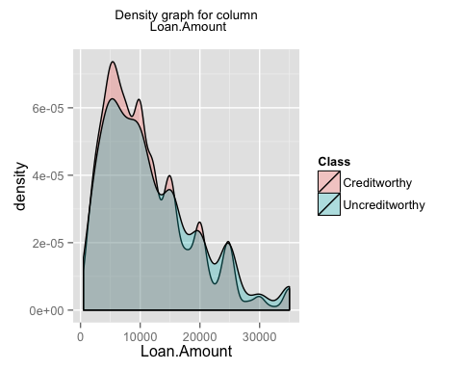

## [1] "generating graph for the column Loan.Term"

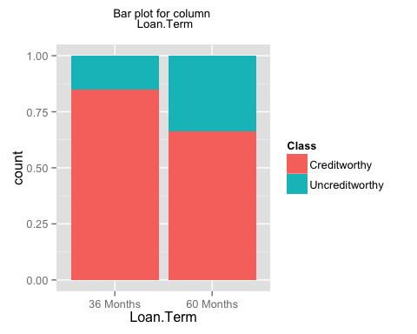

## [1] "generating graph for the column Employment.Length"

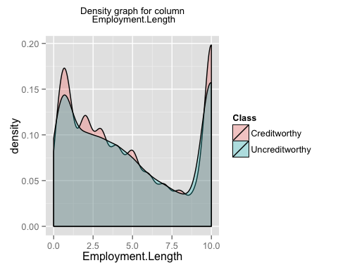

## [1] "generating graph for the column Home.Ownership"

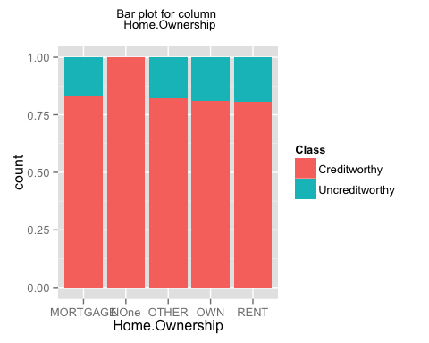

## [1] "generating graph for the column Annual.Income"

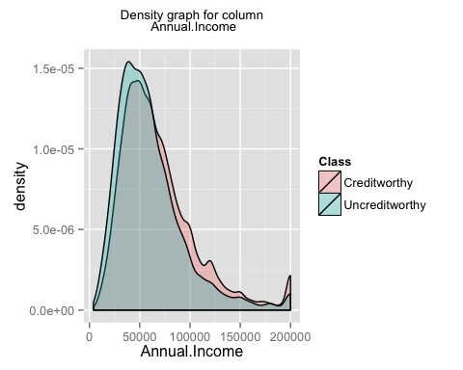

## [1] "generating graph for the column Loan.Purpose"

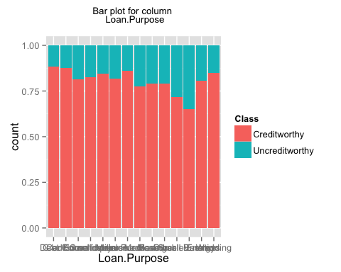

## [1] "generating graph for the column Address.State"

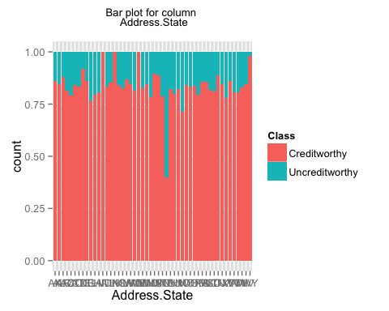

## [1] "generating graph for the column Debt.To.Income.Ratio"

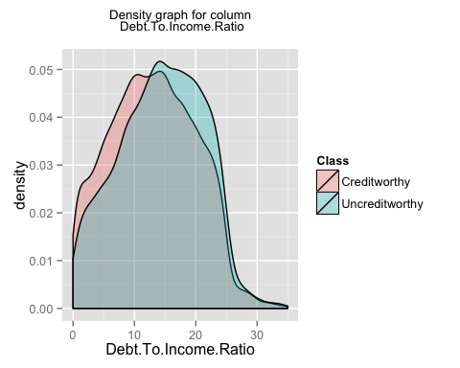

## [1] "generating graph for the column No..Delinquencies.In.Last.2.Years"

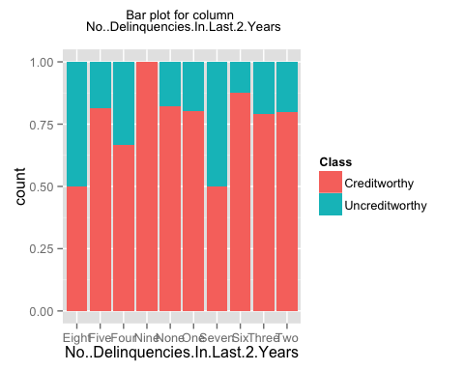

## [1] "generating graph for the column Earliest.Credit.Line.Opened"

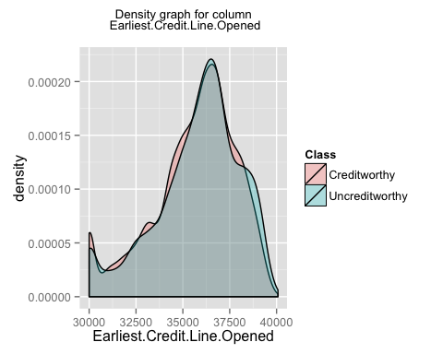

## [1] "generating graph for the column FICO.Credit.Score"

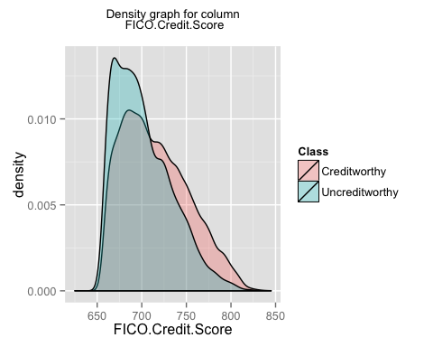

## [1] "generating graph for the column No..Inquiries.In.Last.6.Months"

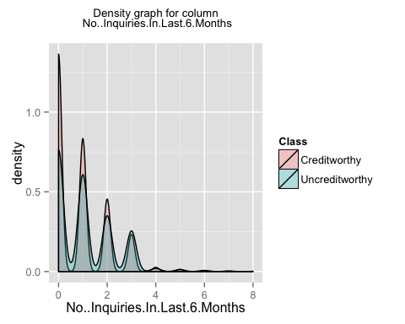

## [1] "generating graph for the column Months.Since.Last.Delinquency"

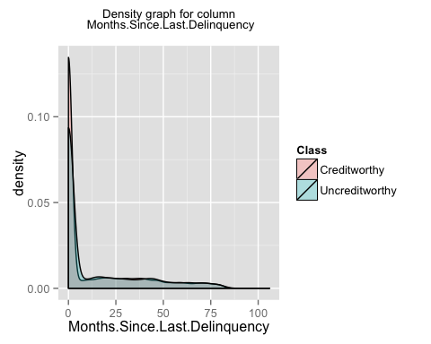

## [1] "generating graph for the column No..Of.Credit.Lines"

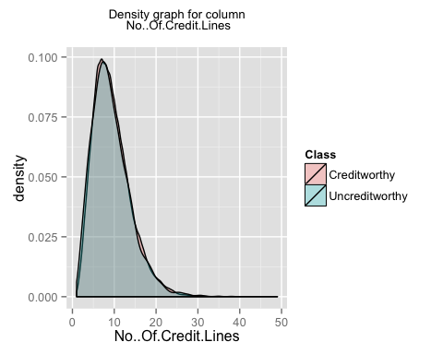

## [1] "generating graph for the column No..Adverse.Public.Records"

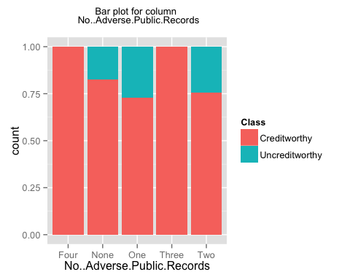

## [1] "generating graph for the column Total.Credit.Balance"

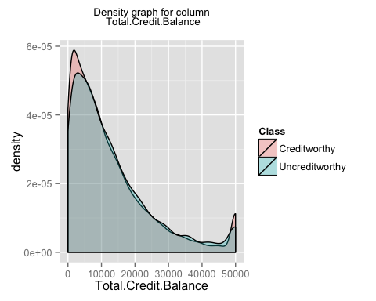

## [1] "generating graph for the column Use.Of.Credit.Line"

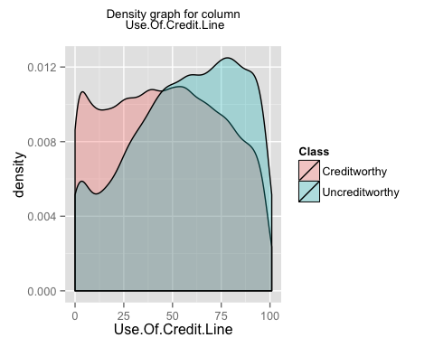

## [1] "generating graph for the column Total.Number.Of.Credit.Lines"

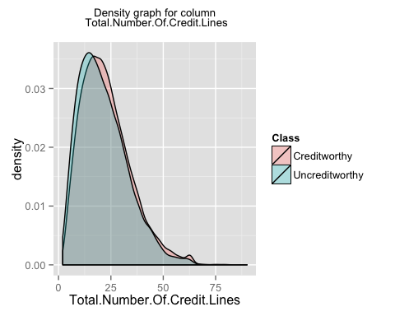

## [1] "generating graph for the column Loan.Application.Description"

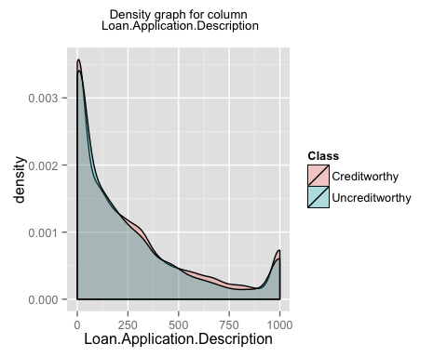

## [1] "generating graph for the column No..Of.Public.Record.Bankruptcies"

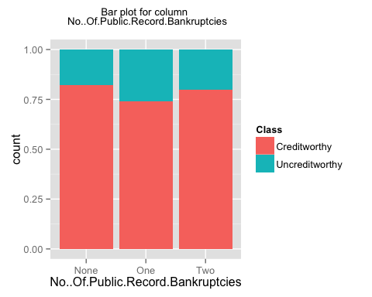

## [1] "generating graph for the column Class"

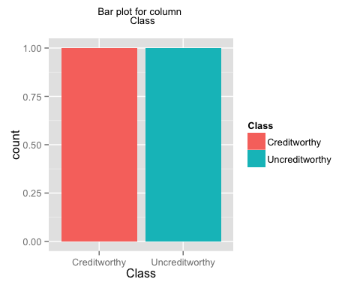

## [1] "finished generating the first set of plots i.e. individual plots for each column"  
## [1] "now generating the second set of plots i.e. plots for a pair of columns"

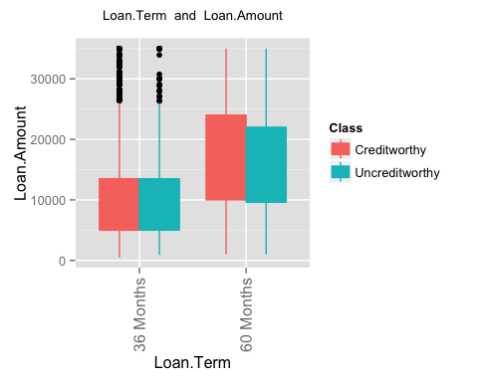 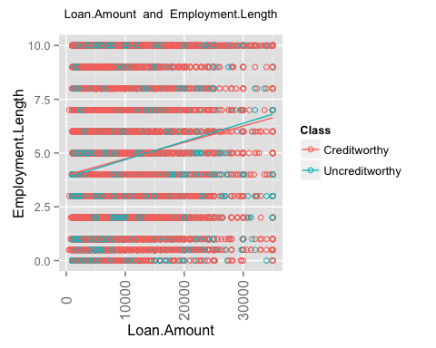 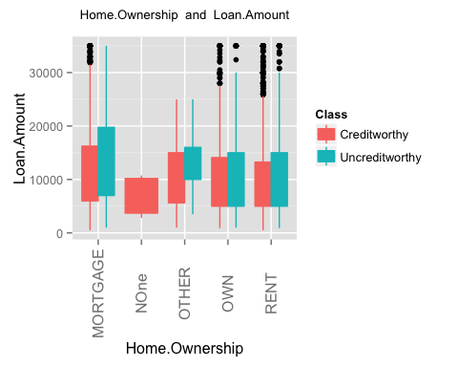 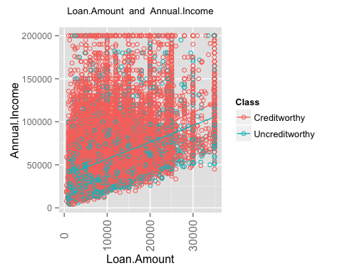 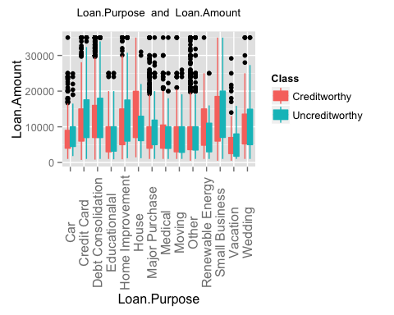 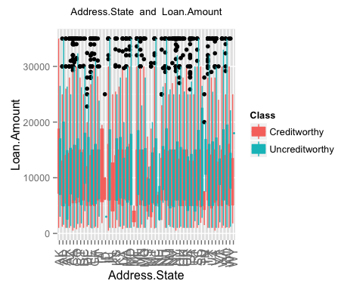 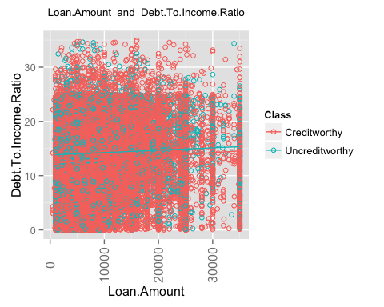 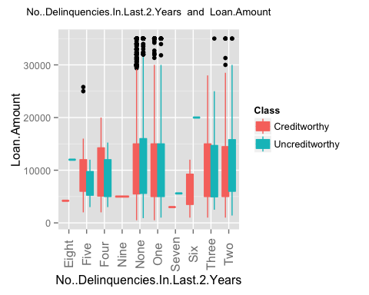 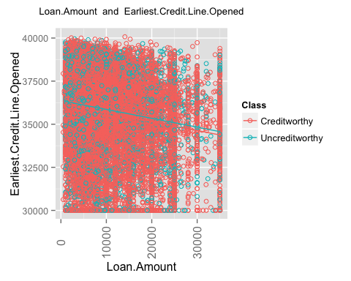 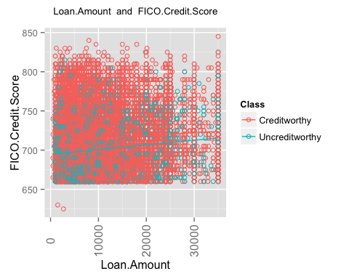 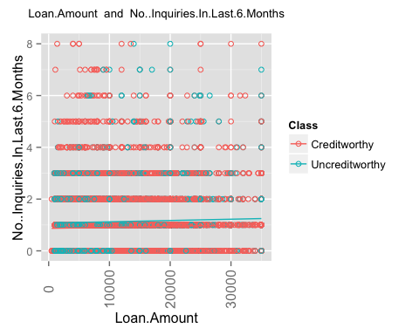 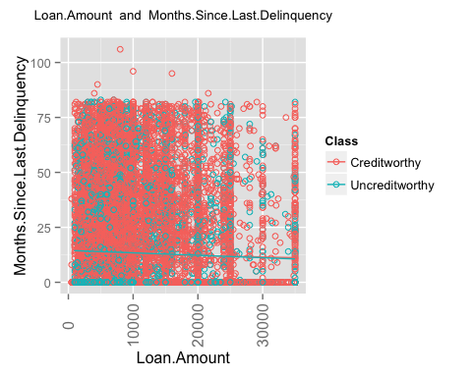 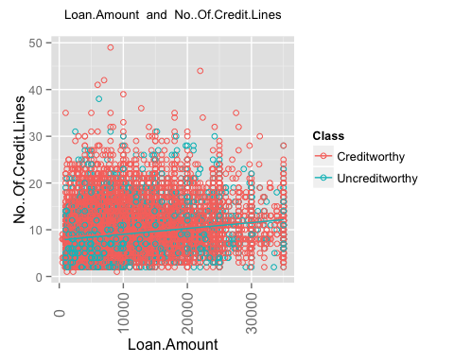 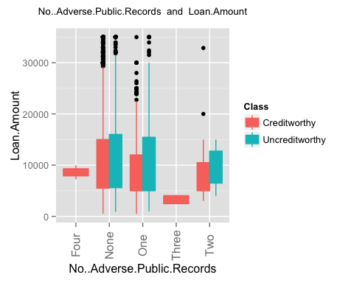 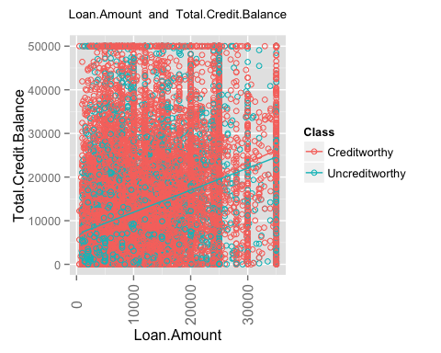 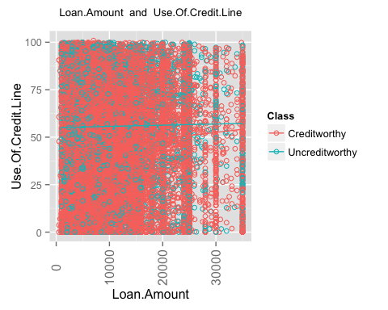 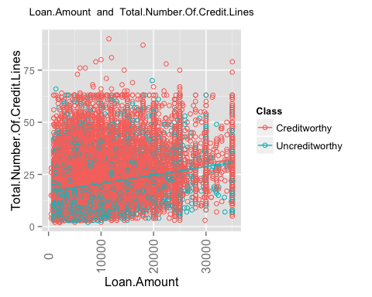 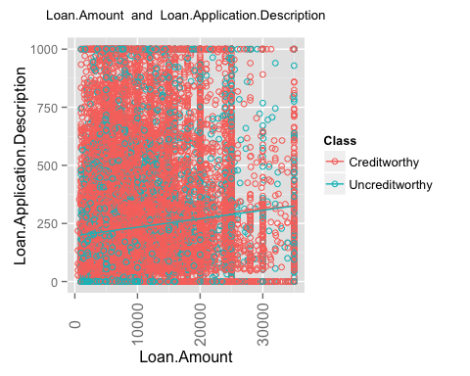 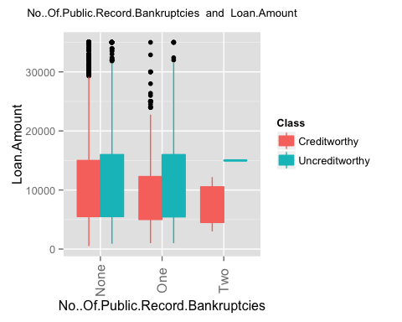 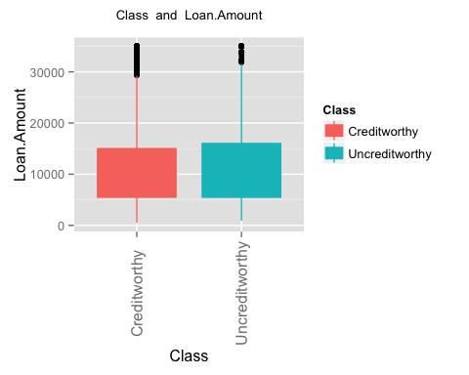 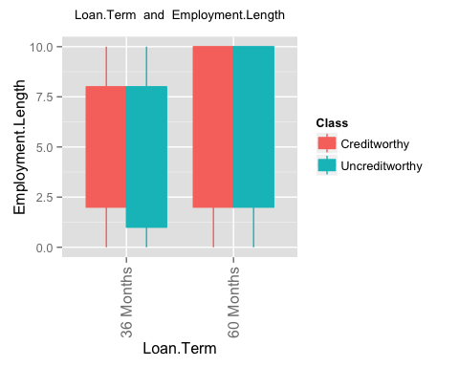 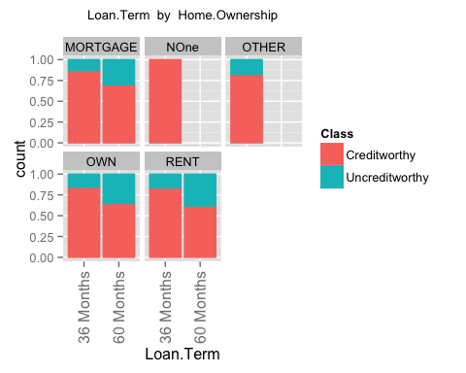 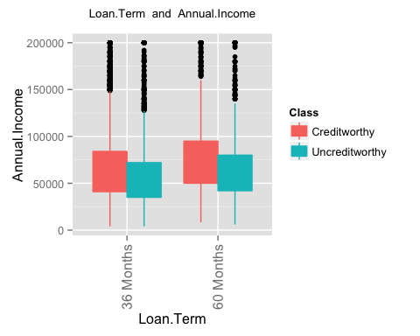 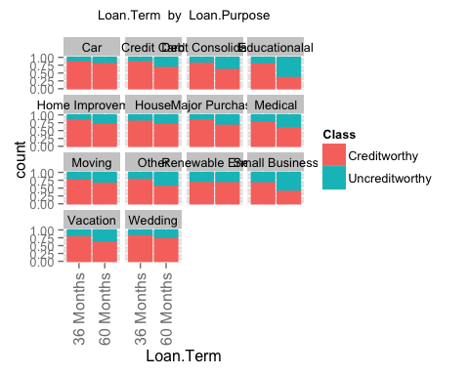 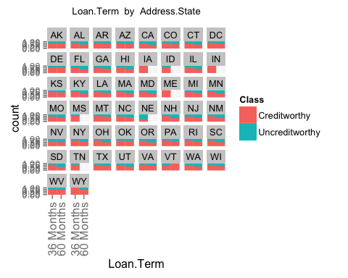 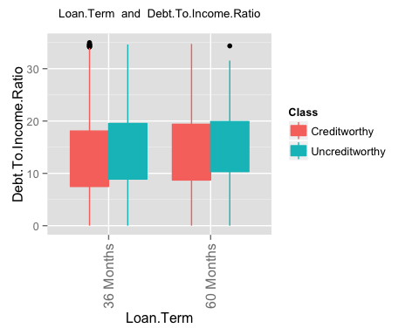 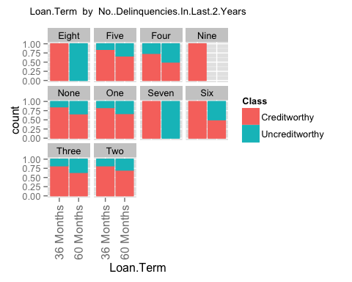 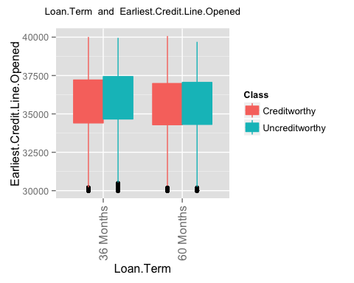 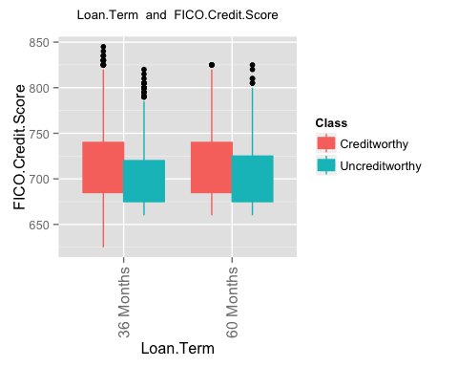 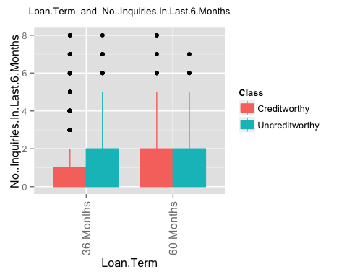 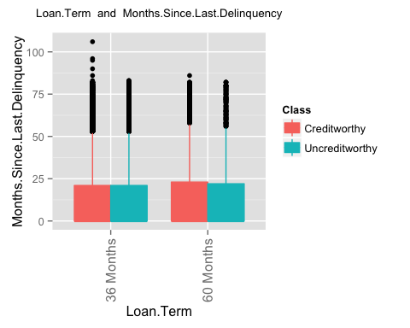 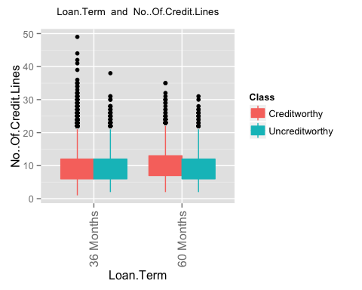 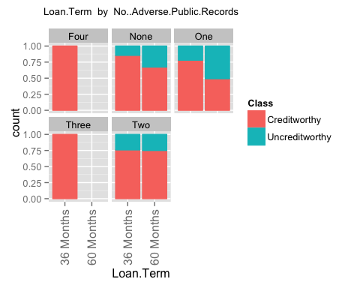 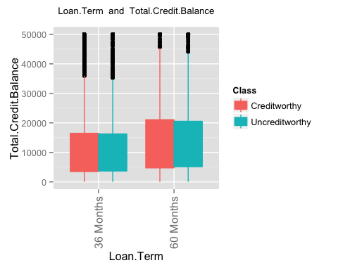 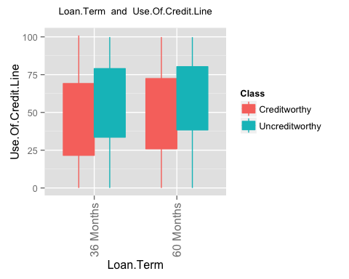 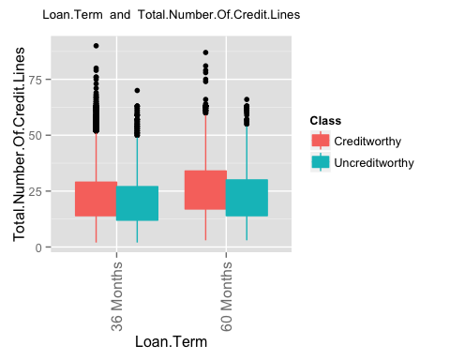 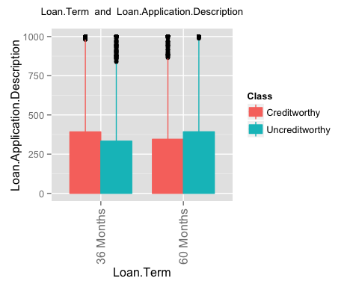 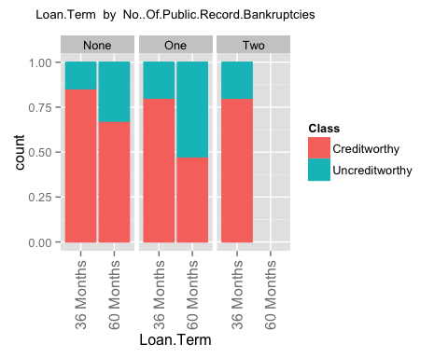 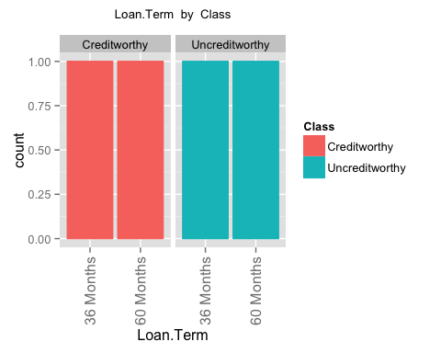 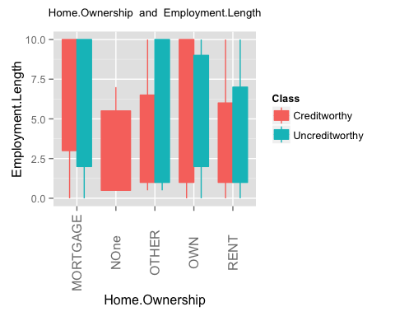 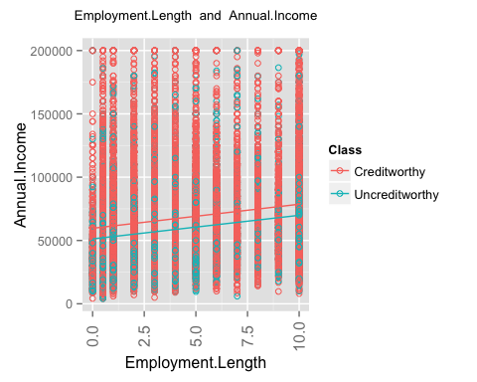 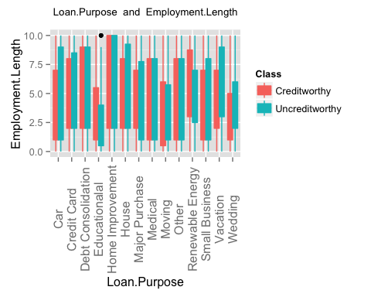 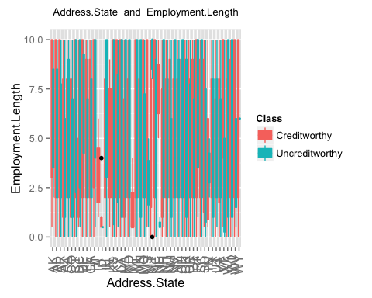 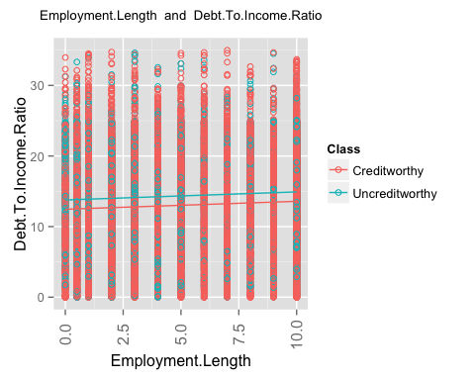 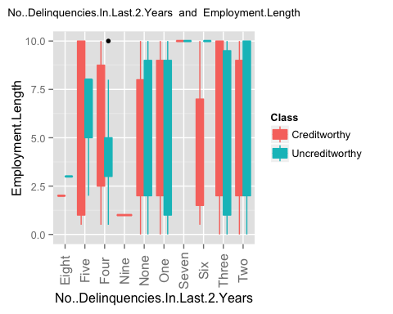 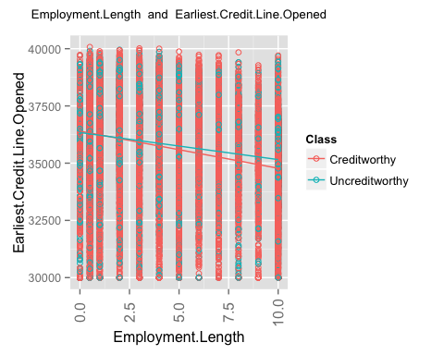 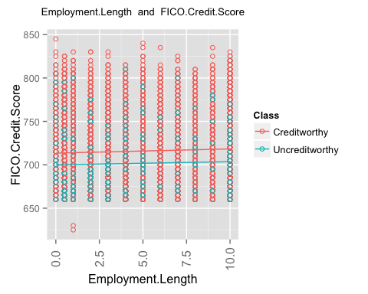 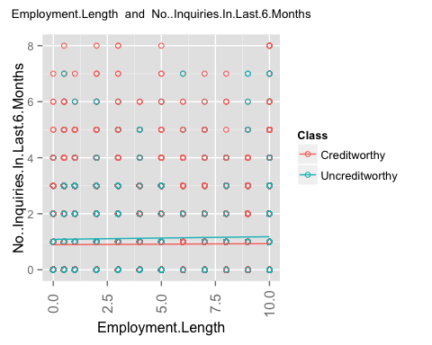 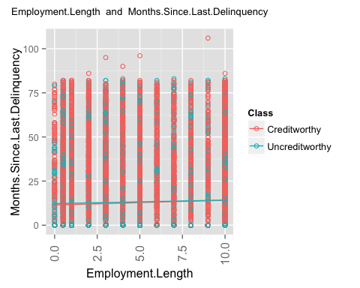 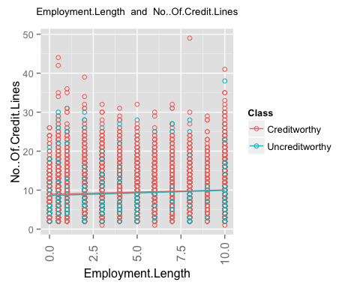 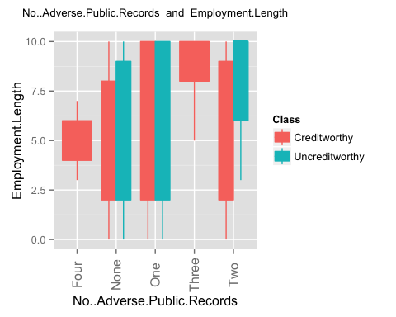 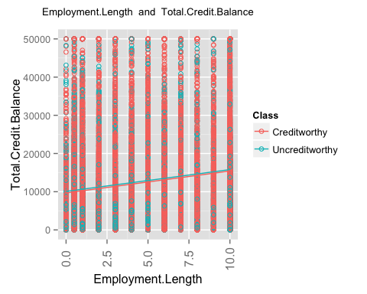 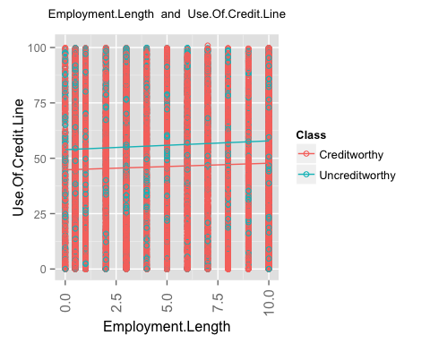 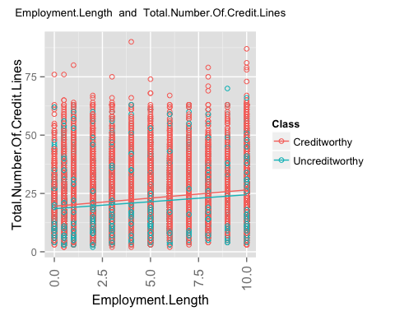 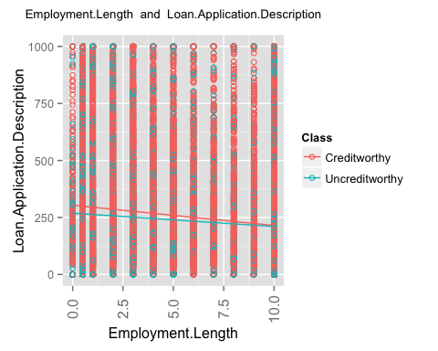 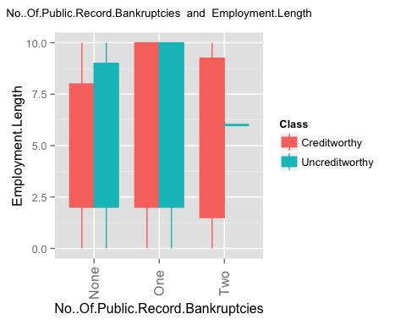 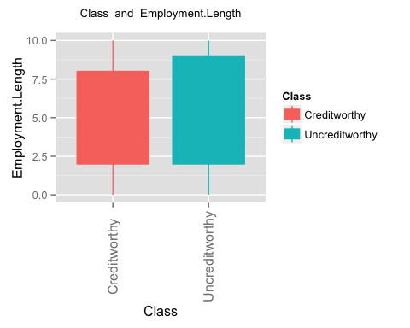 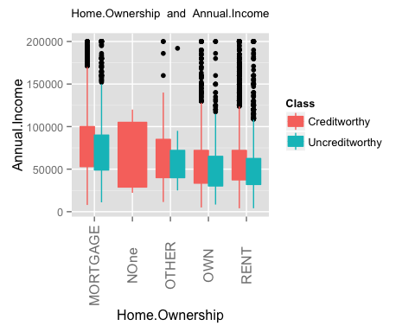 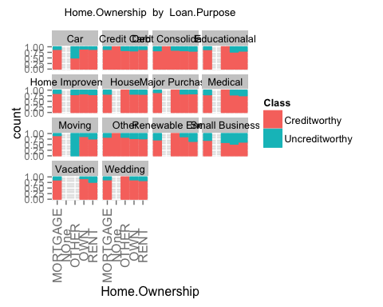 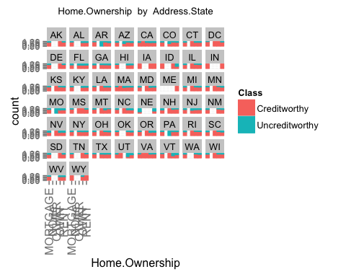 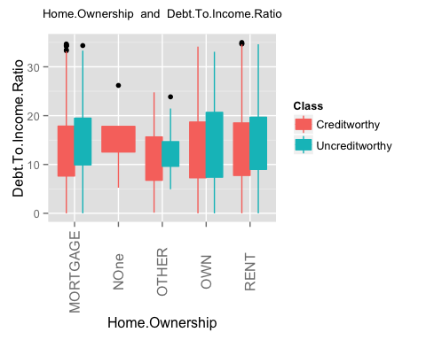 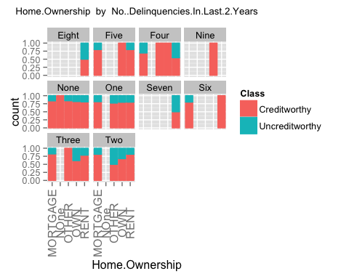 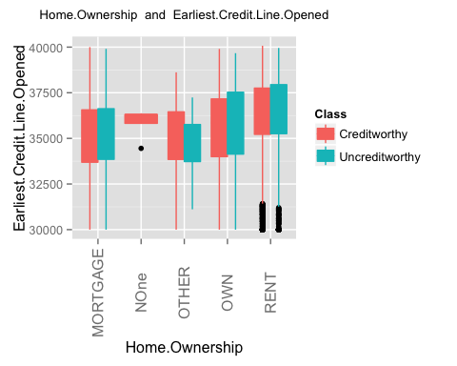 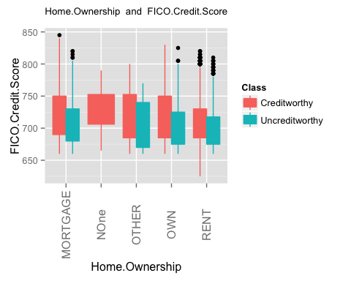 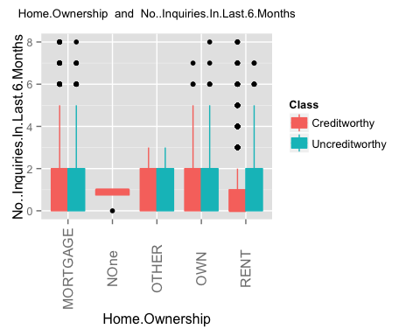 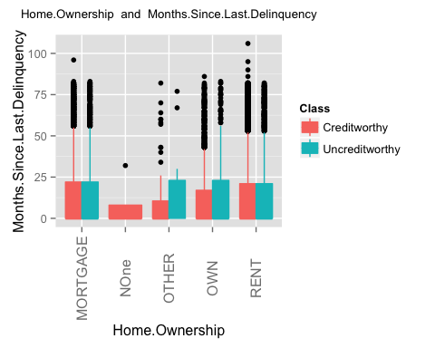 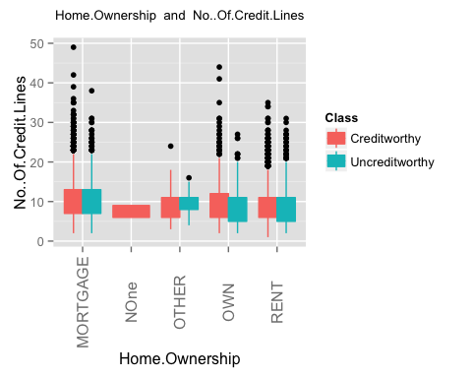 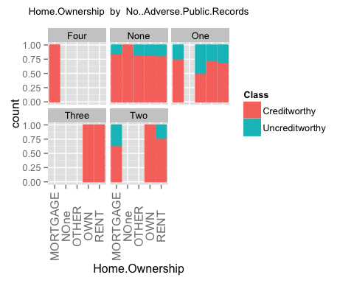 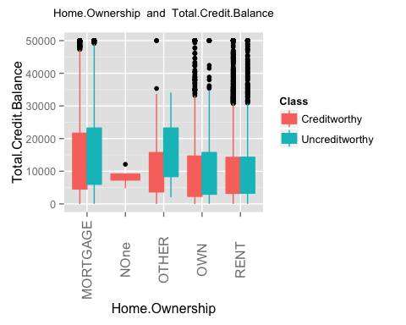 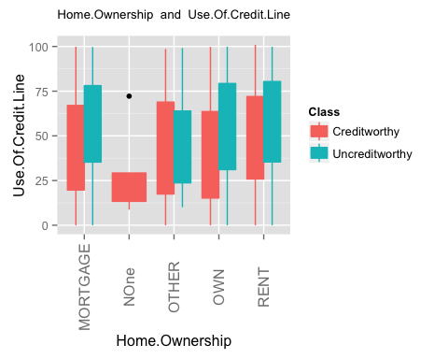 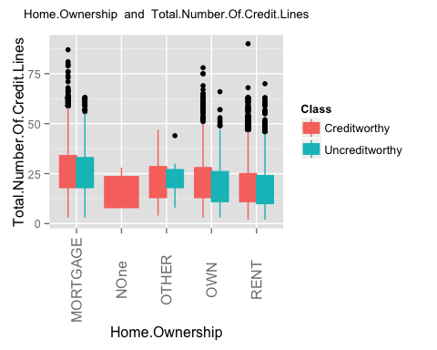 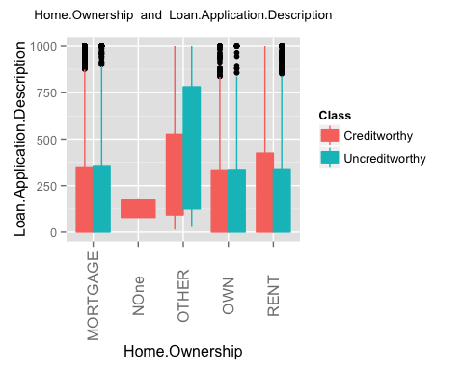 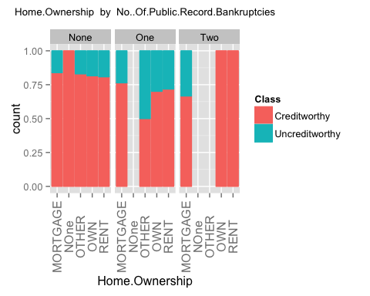 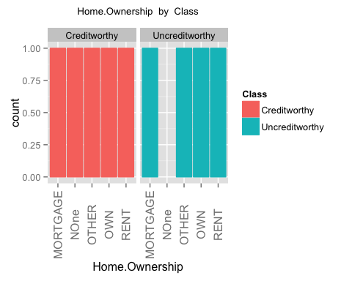 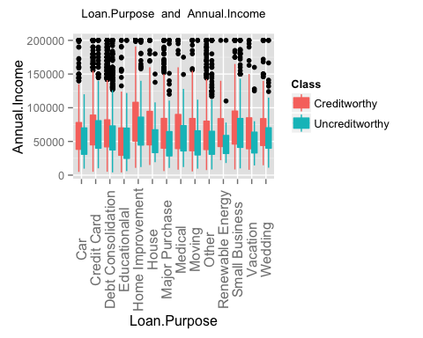 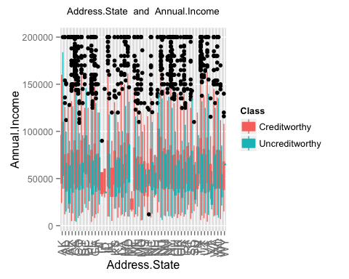 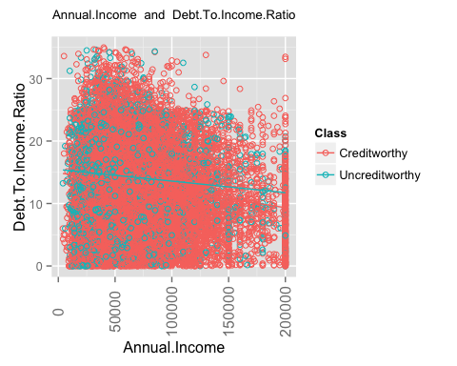 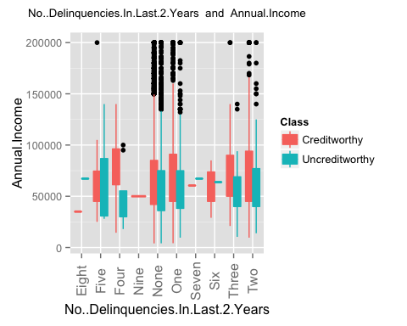 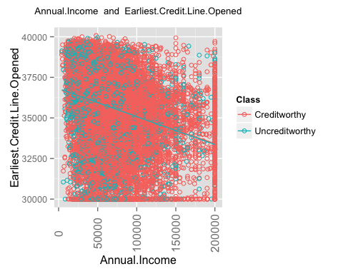 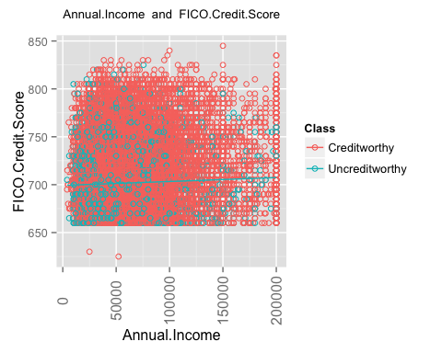 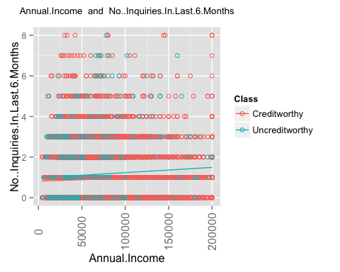 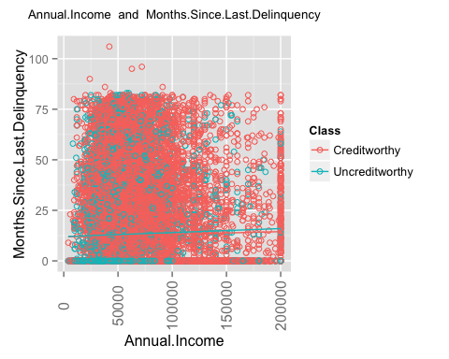 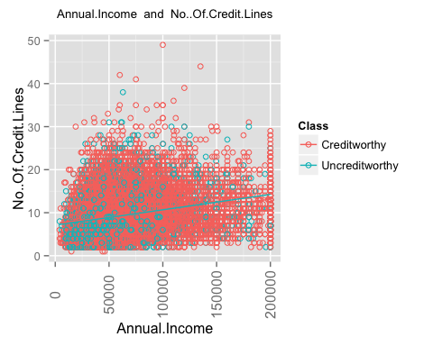 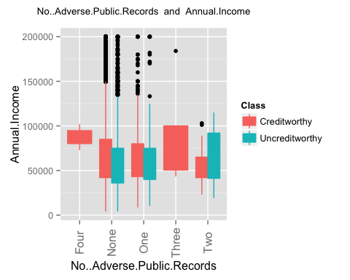 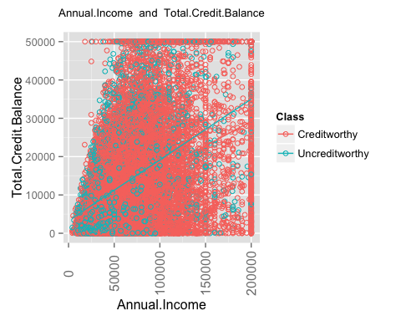 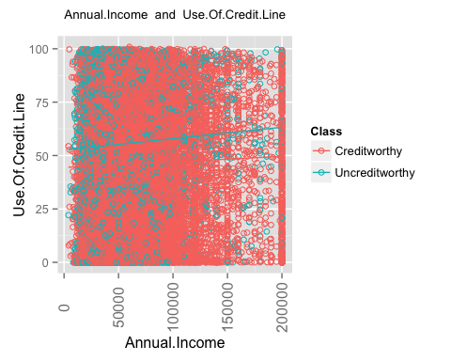 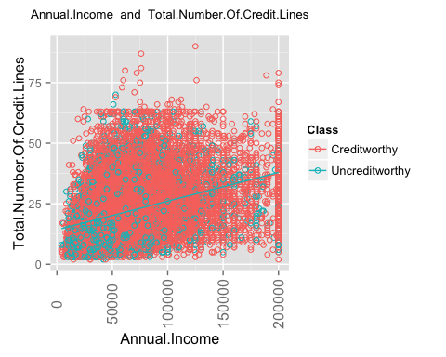 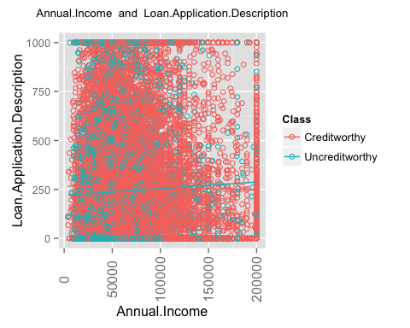 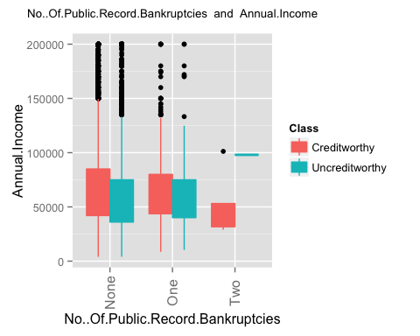 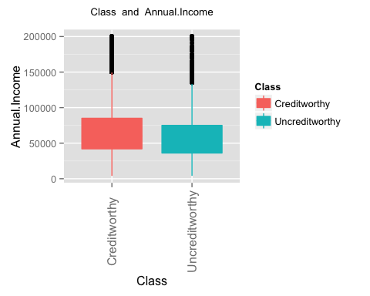 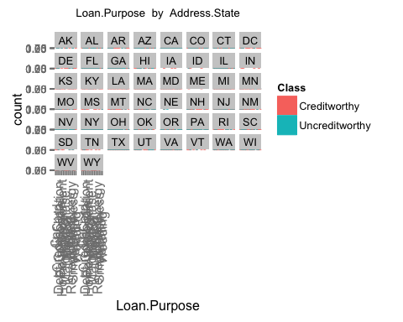 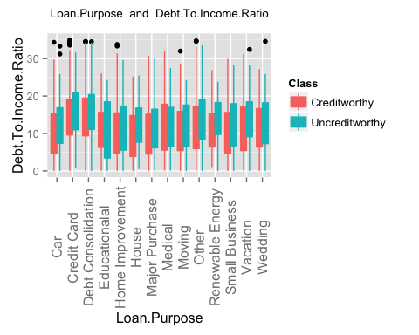 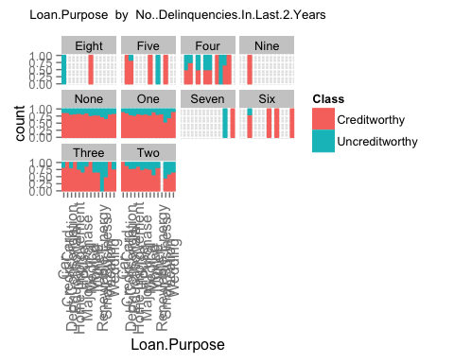 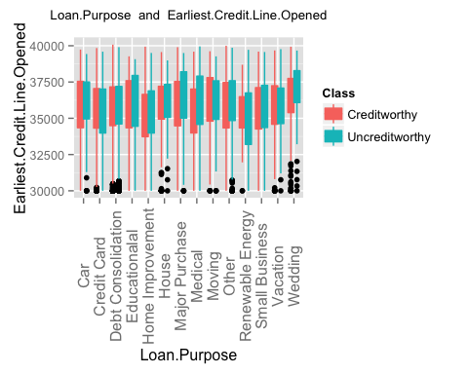 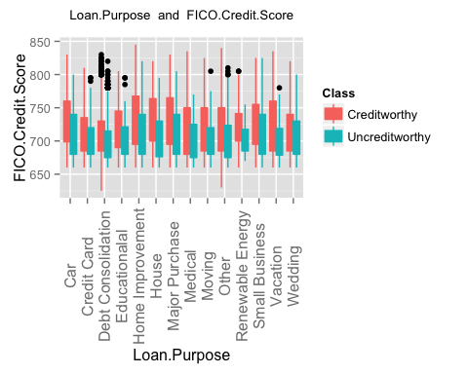 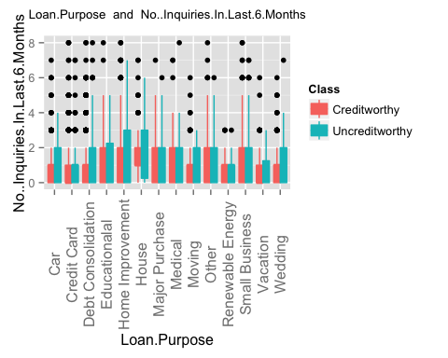 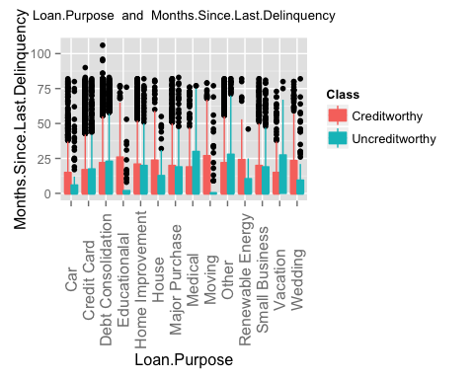 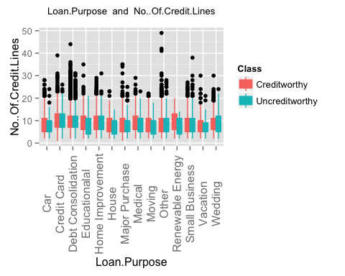 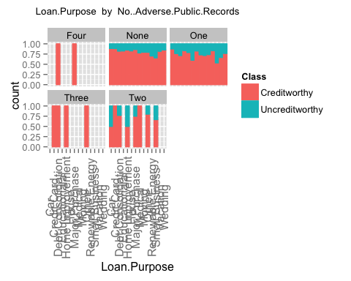 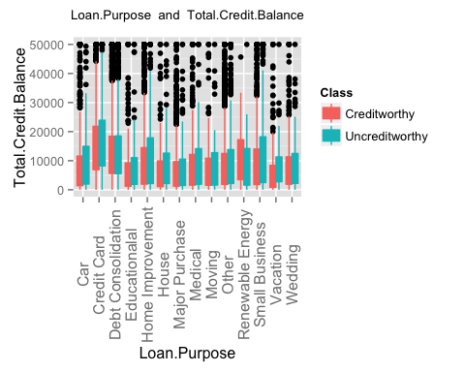 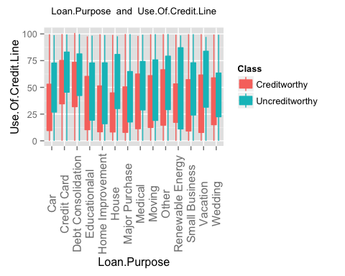 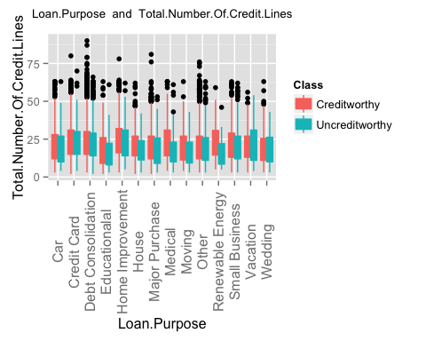 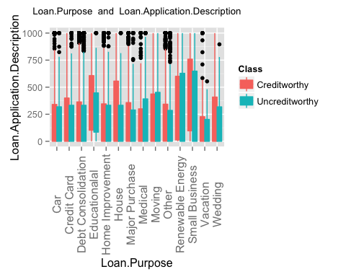 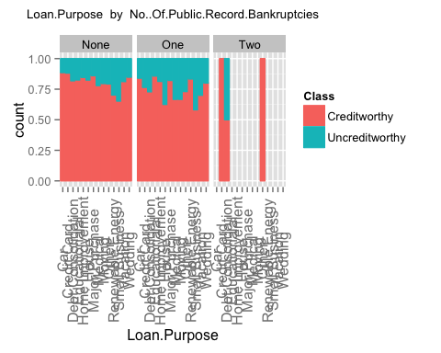 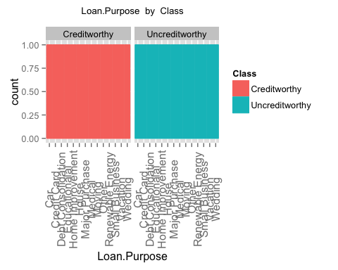 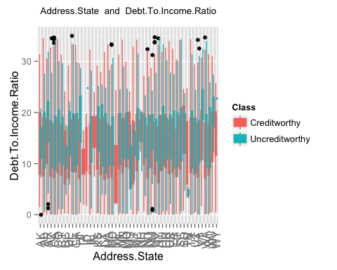 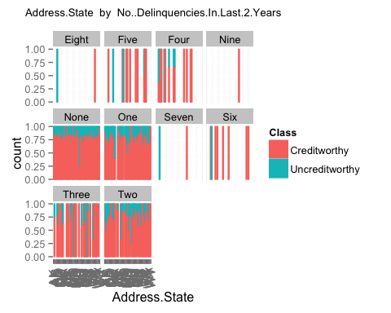 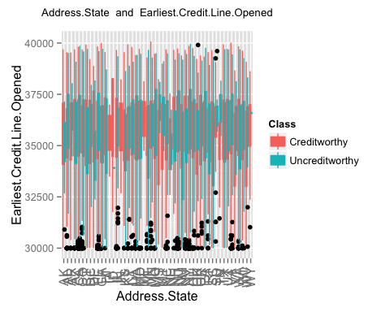 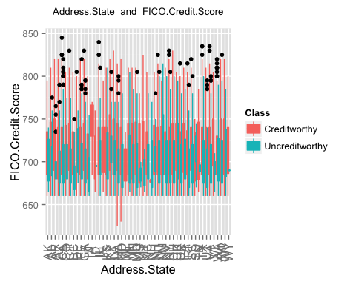 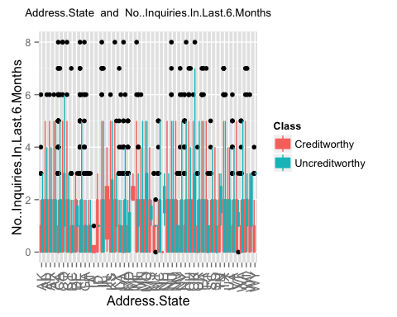 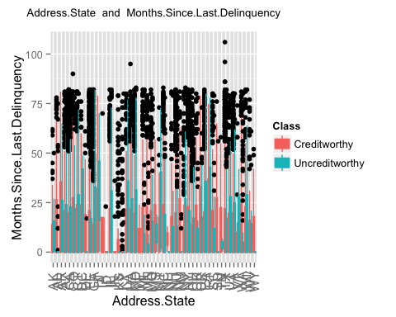 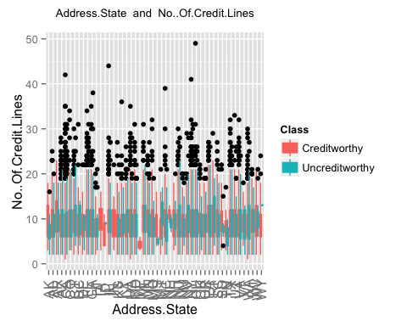 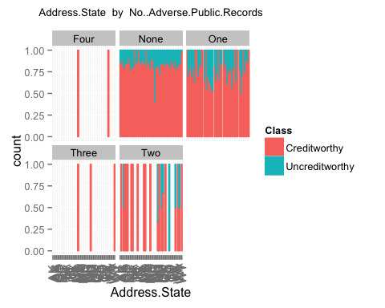 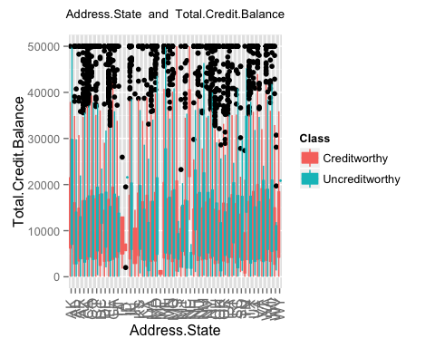 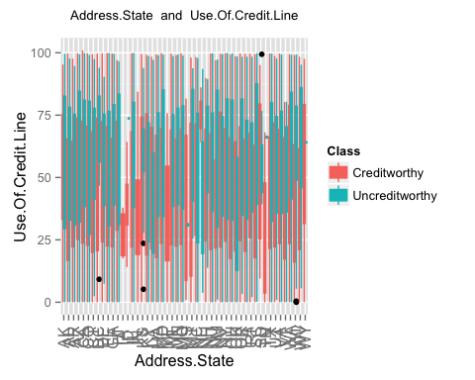 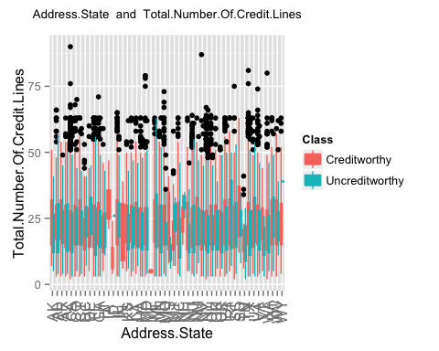 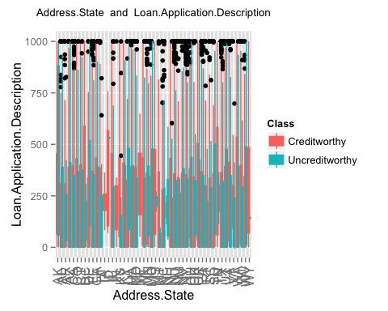 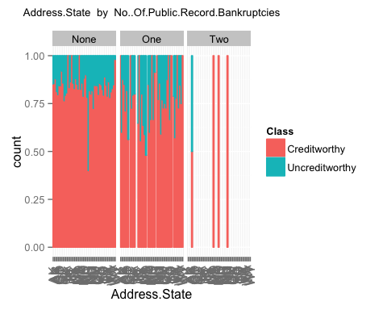 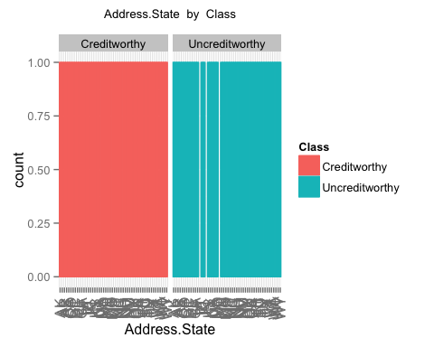 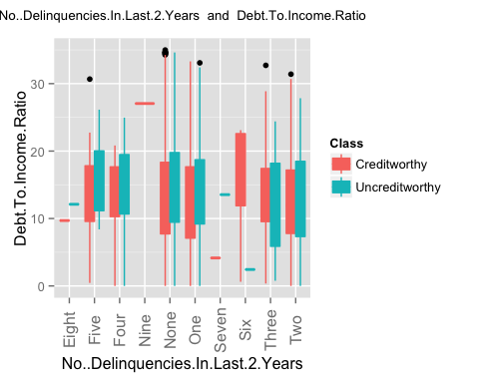 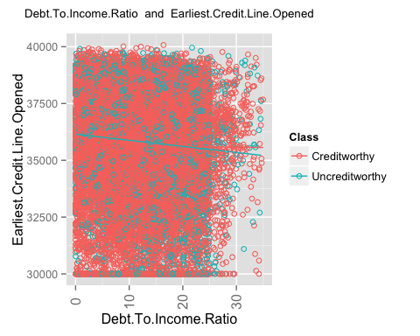 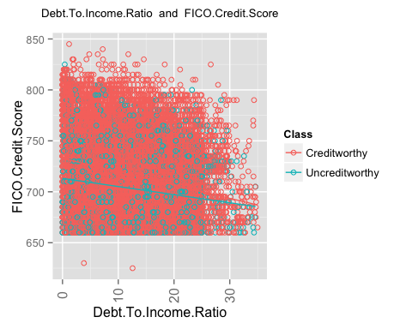 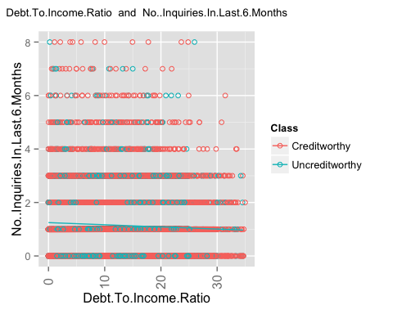 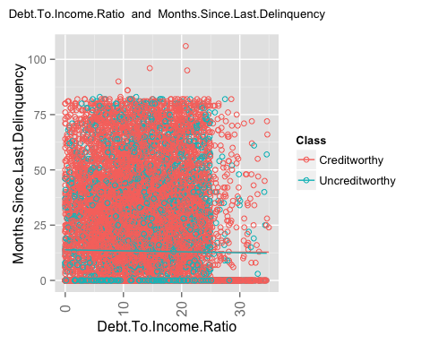 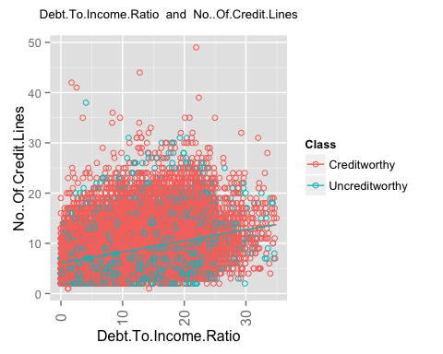 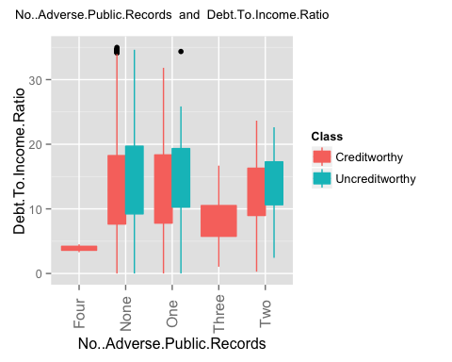 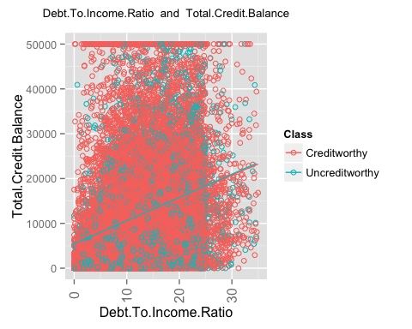 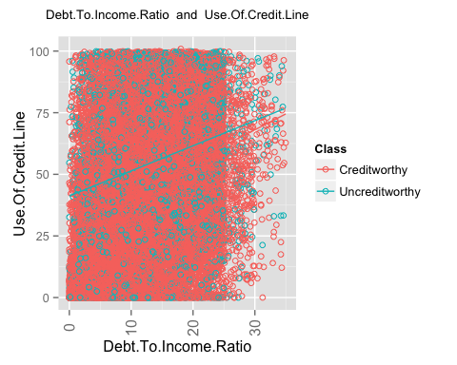 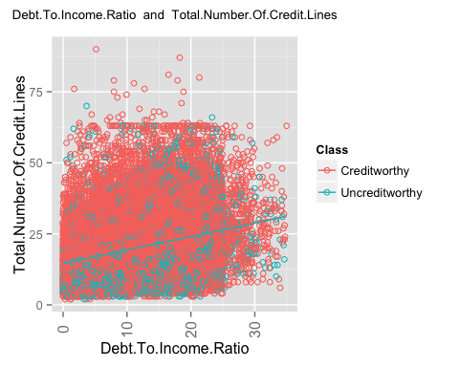 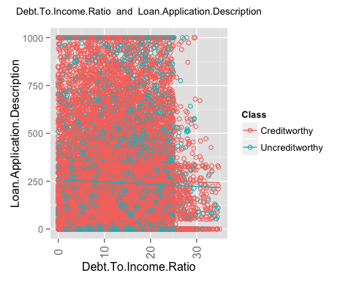 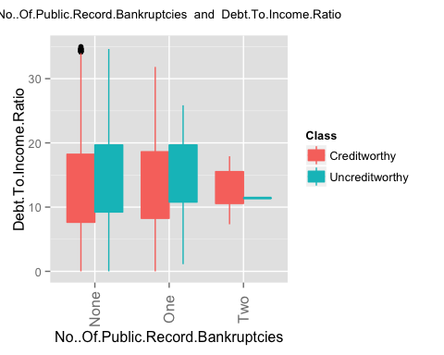 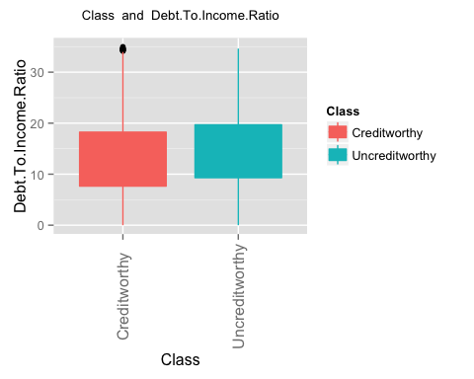 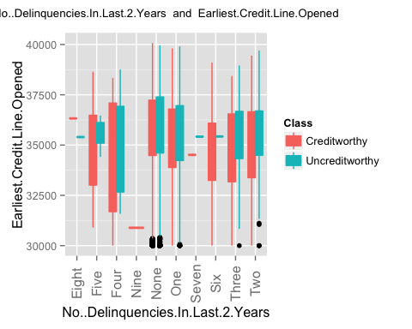 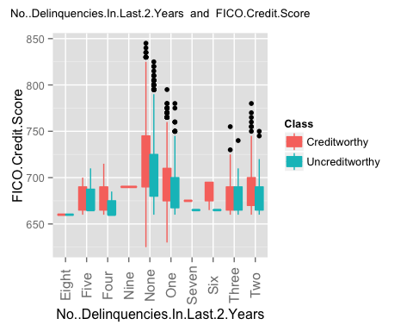 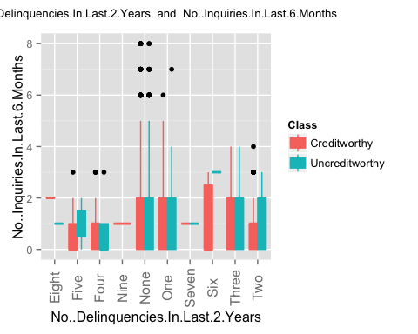 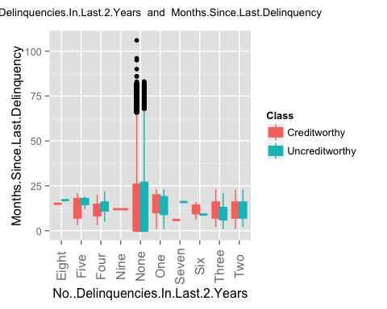 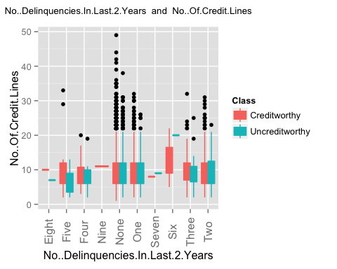 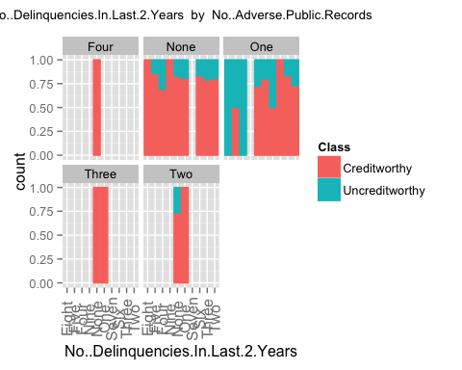 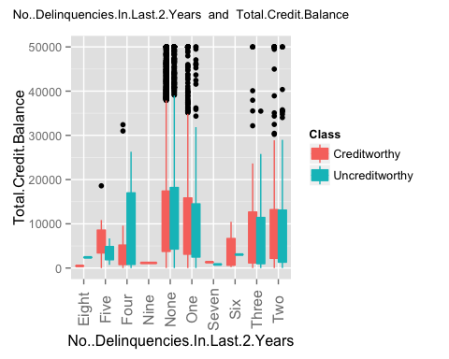 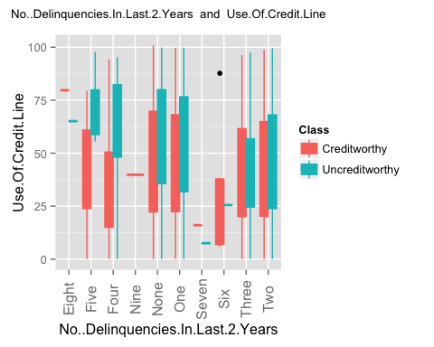 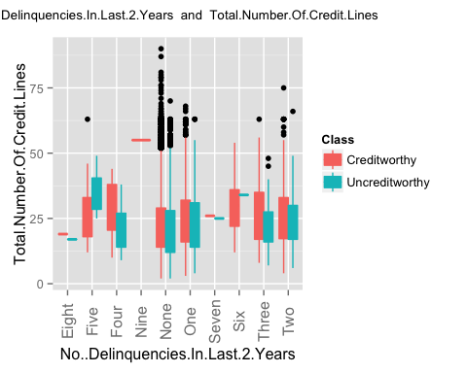 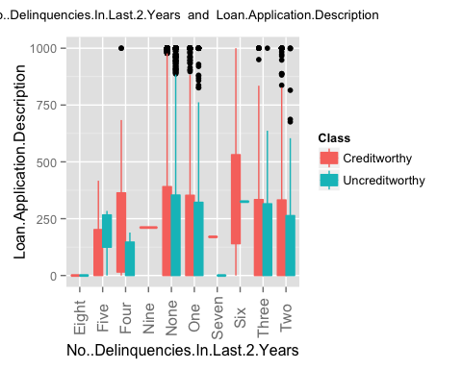 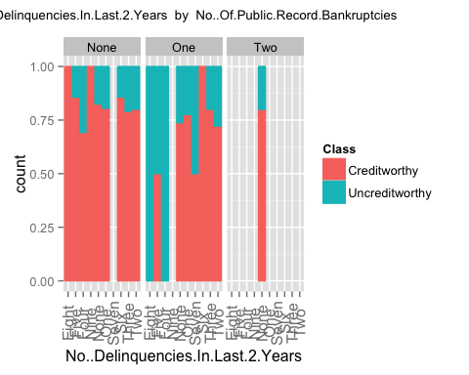 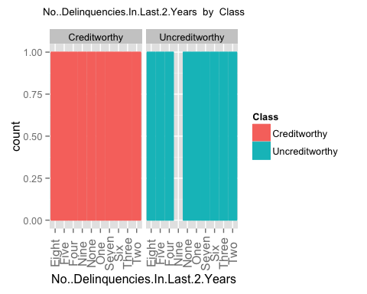 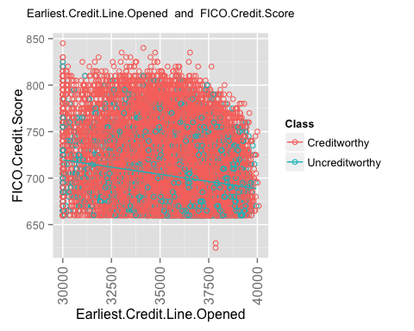 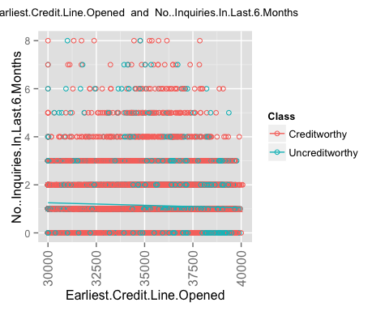 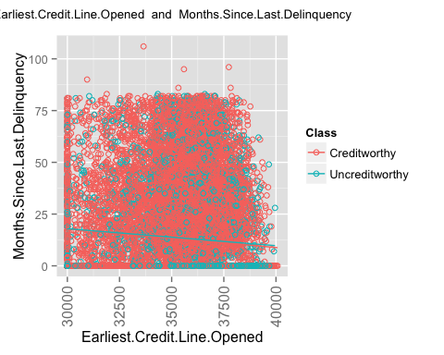 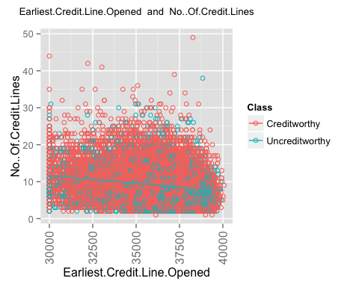 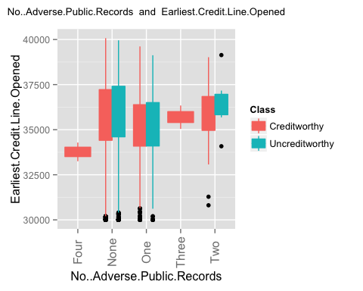 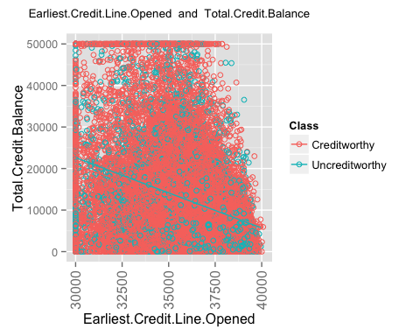 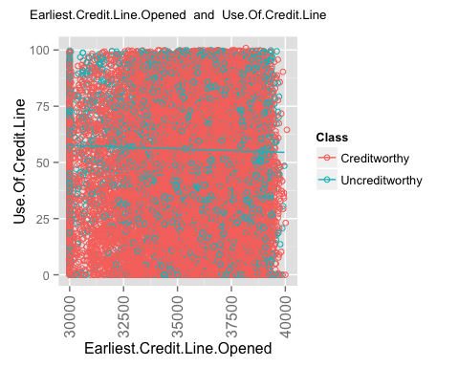 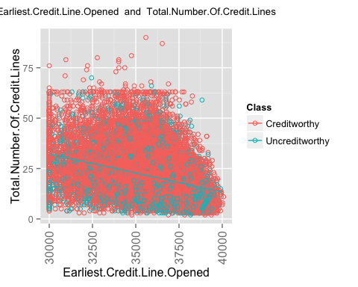 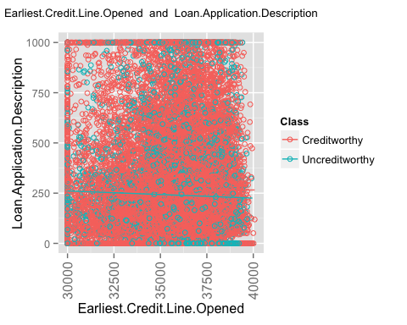 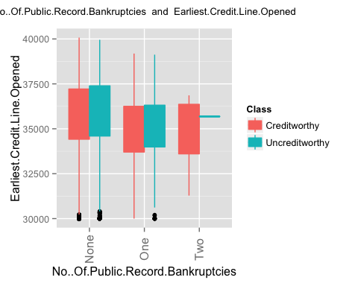 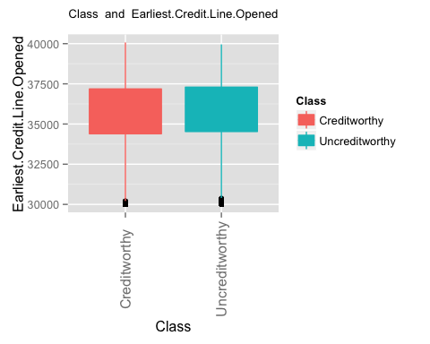 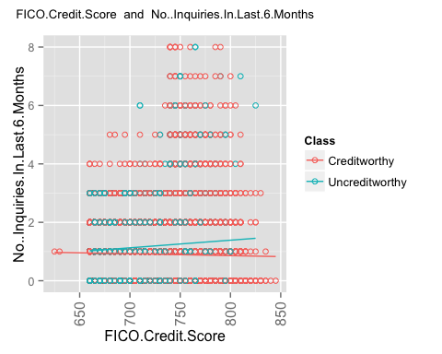 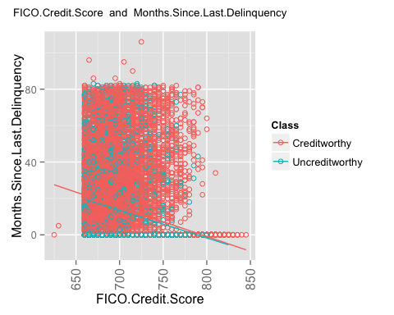 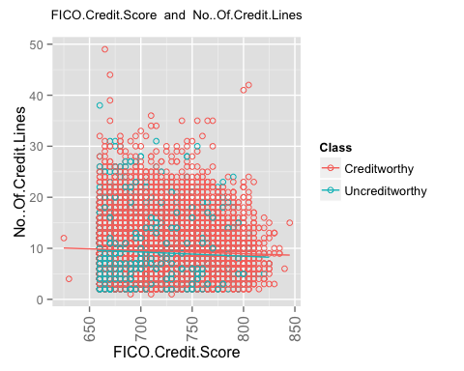 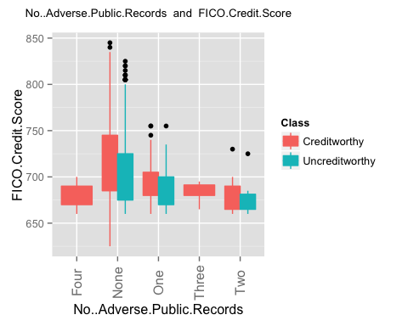 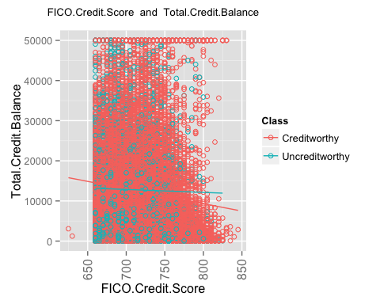 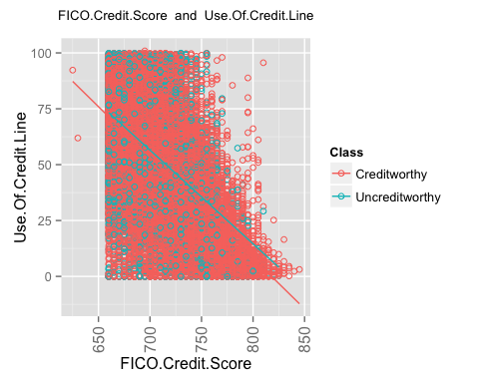 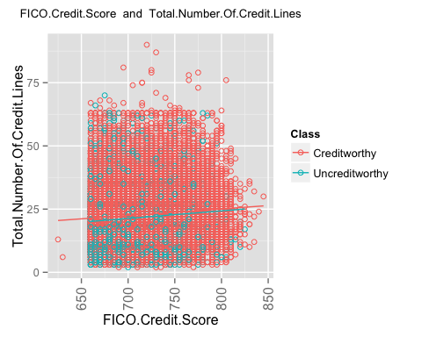 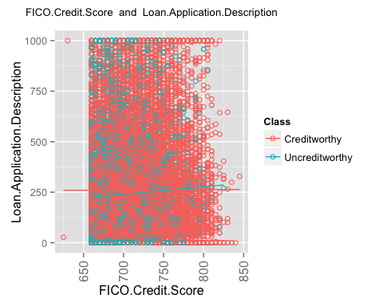 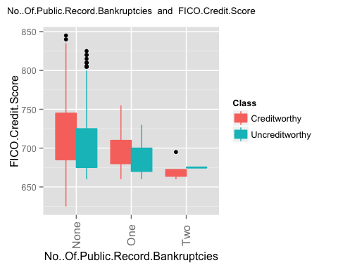 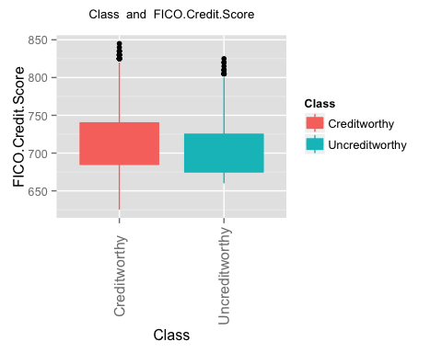 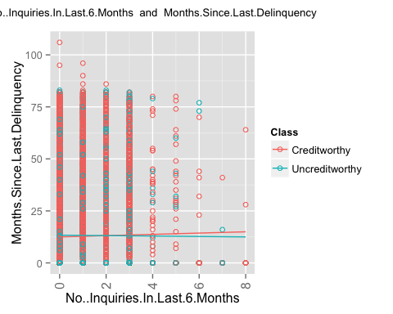 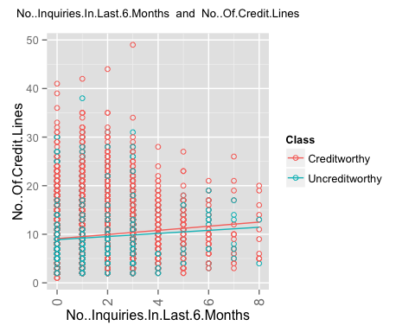 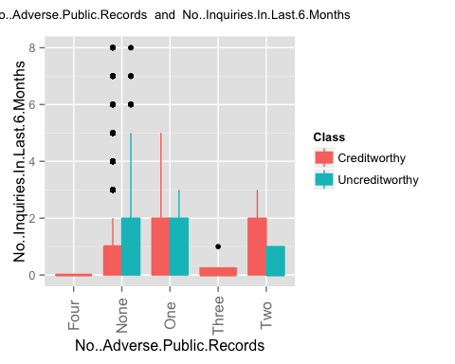 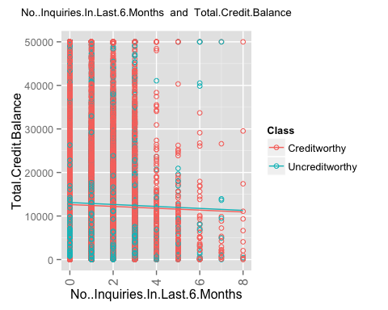 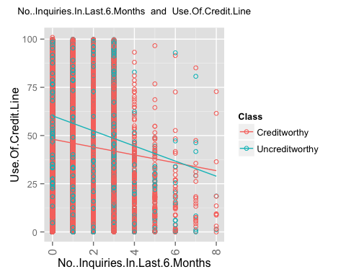 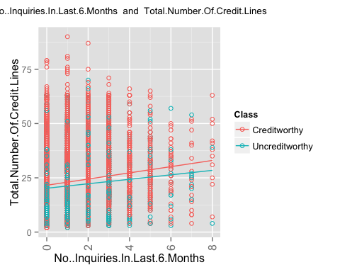 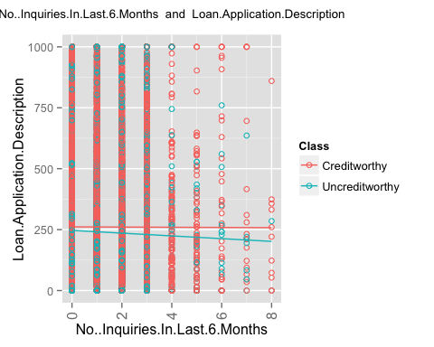 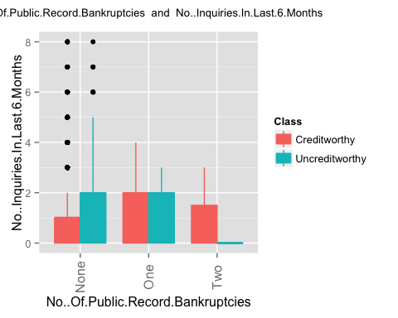 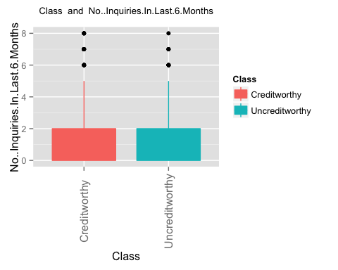 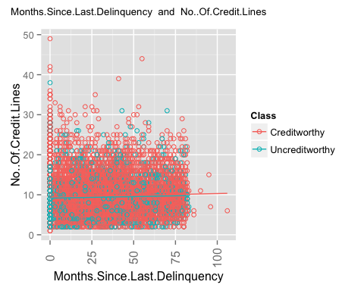 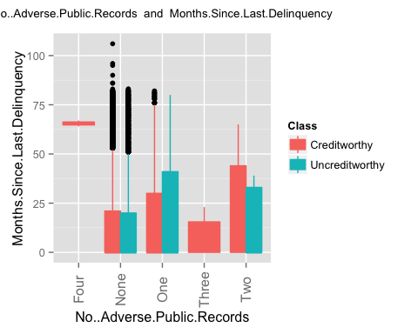 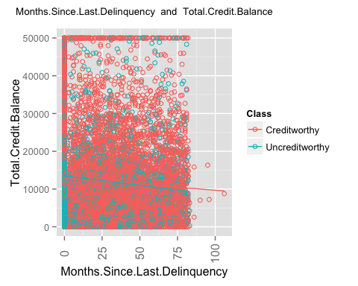 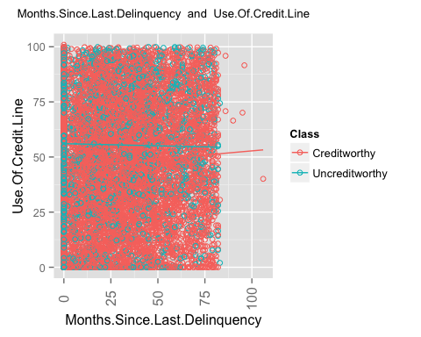 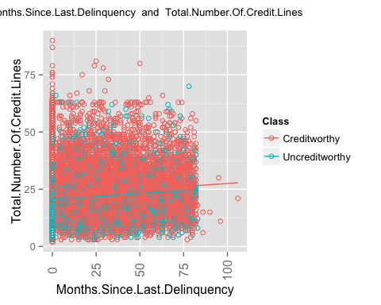 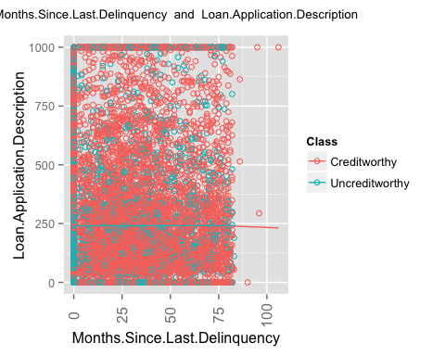 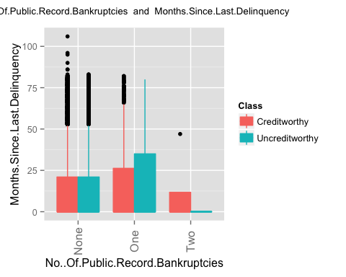 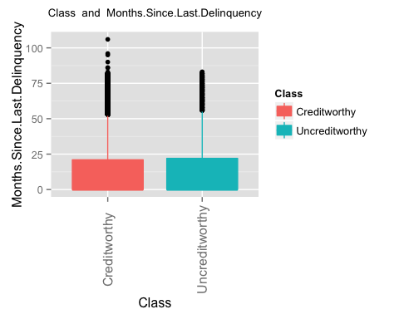 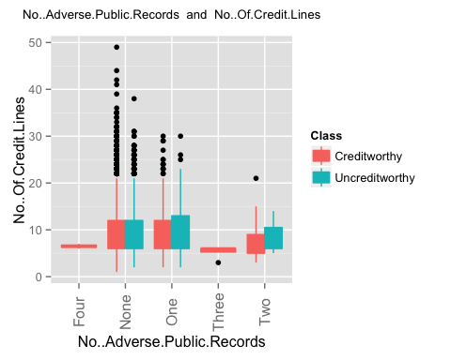 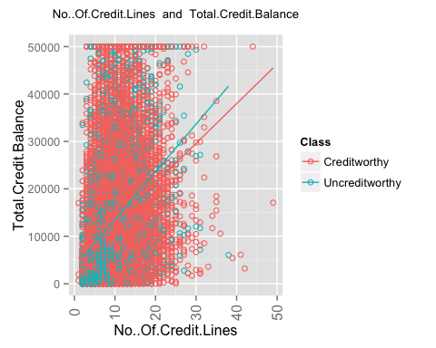 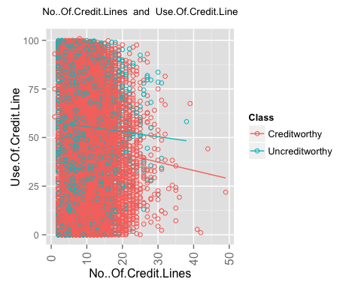 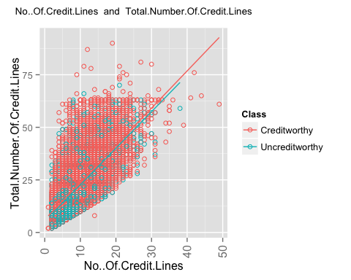 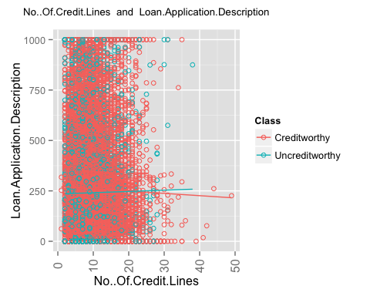 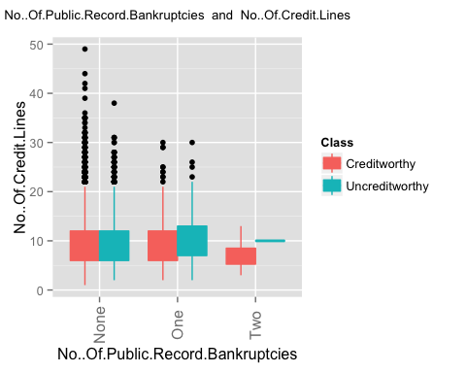 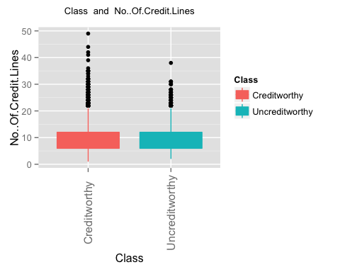 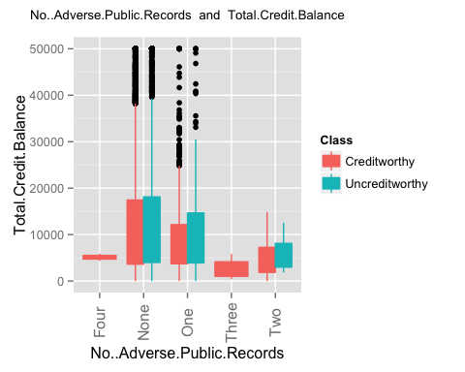 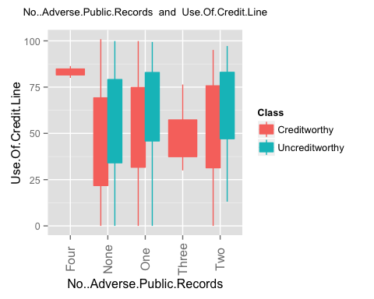 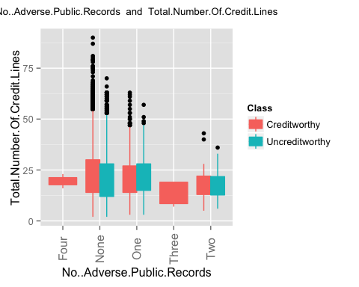 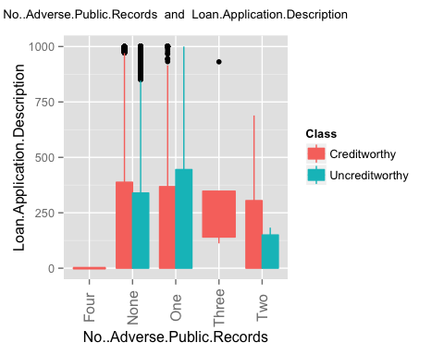 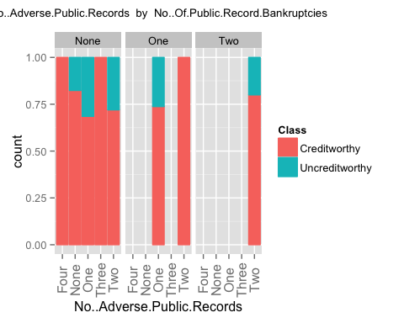 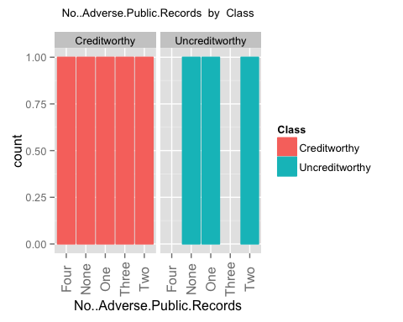 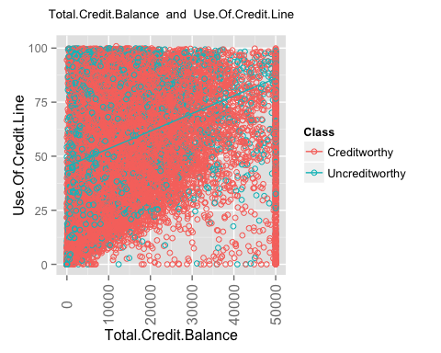 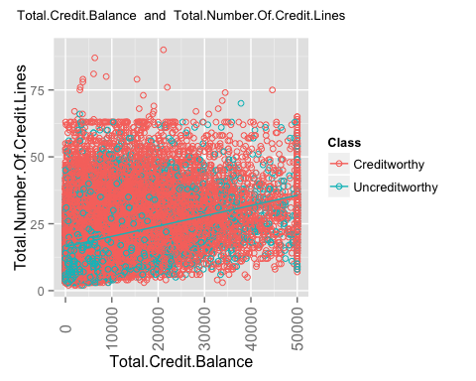 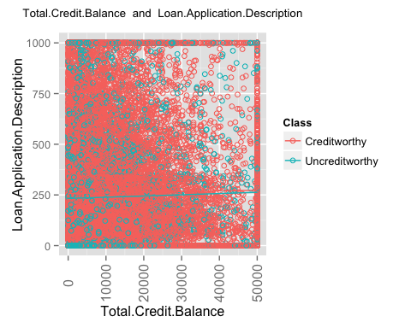 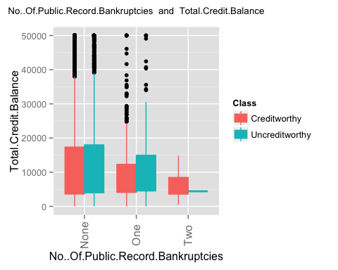 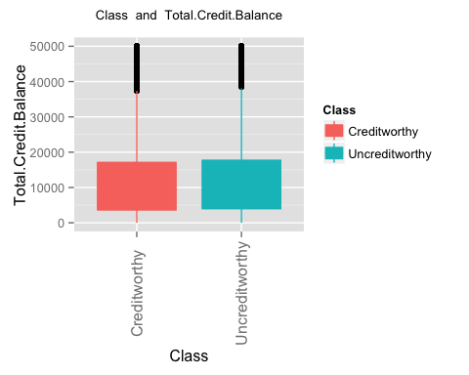 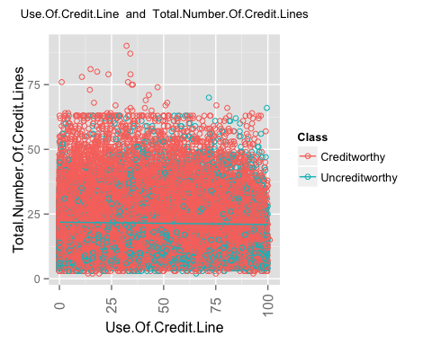 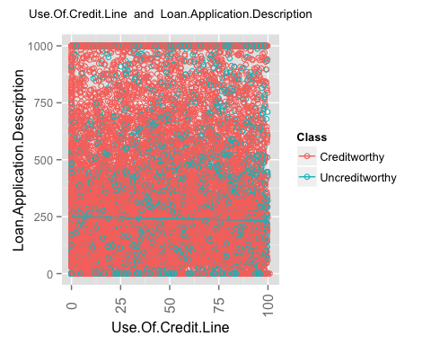 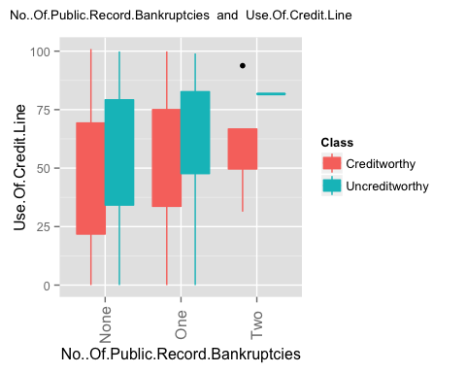 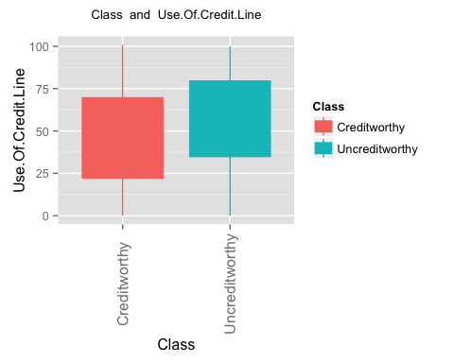 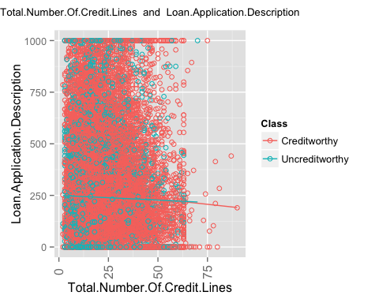 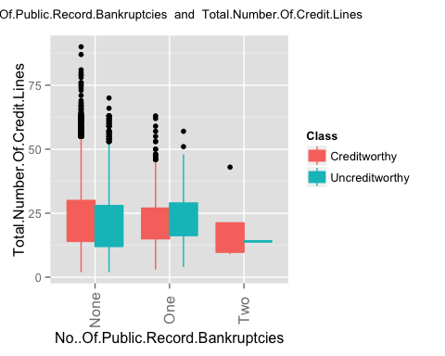 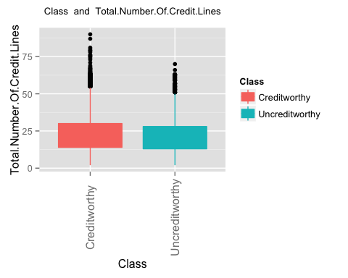 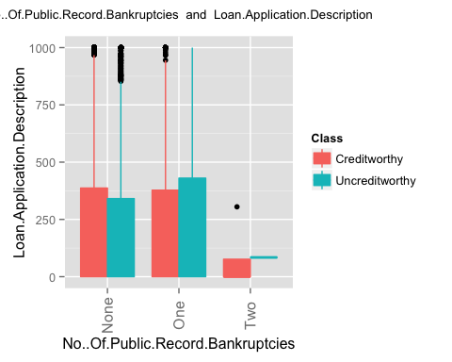 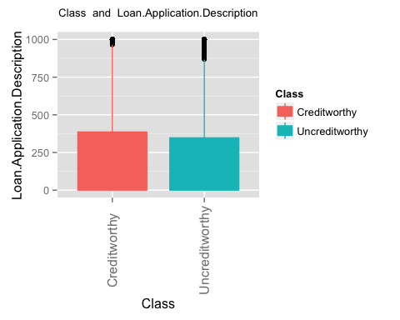

## [1] "finished generating the second set of plots i.e. plots for a pair of columns"